Squeezelite / Logitech Media Server
Squeezelite is a network music player which could be used with Logitech Media Server(aka. LMS). Eunhasu has LMS inside of itself which is available Tidal, Qobuz and internet radio.
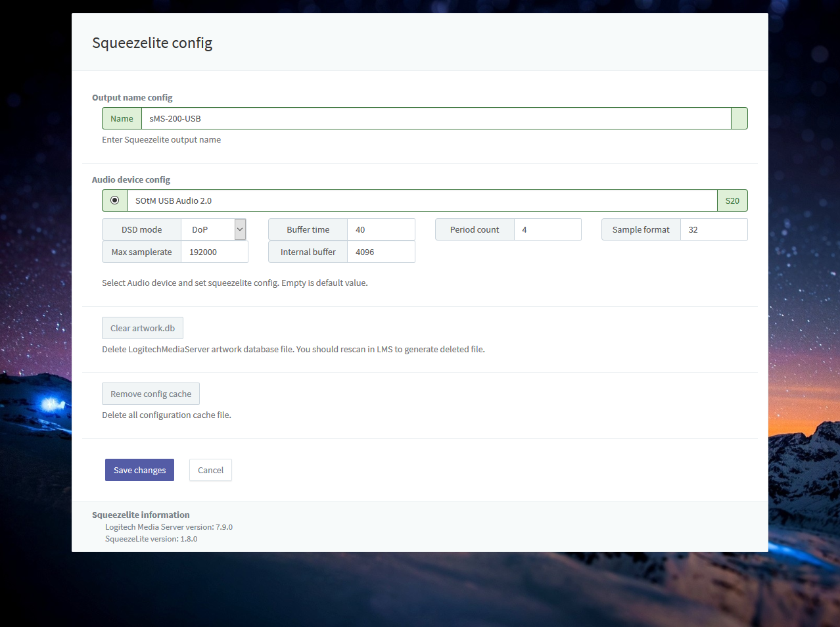
- Name: A name of device Squeezelite appearing on LMS. This could be changed if you need.
- Audio device config: Select a radio button of USB DAC which is going to use and click ‘Save changes’ to use the USB DAC.
  - Setting mode: If you select the default, the audio device is automatically set. If you select Custom, you can set up your own audio device.
  - DSD mode: DSD Sets the playback method of the sound source to DoP or Native DSD. If you are setting up as a native DSD, make sure that the DAC you are using is a device that supports native DSD.
  - Buffer time: Sets the buffer length of the sound source data to be transmitted to the audio device in microseconds.
  - Period count: Sets the transmission period of the sound source data of the audio device.
  - Sample format: Sets the sound source transmission format (sample format) supported by the connected audio device. (Hovering the mouse cursor over the text box will display the maximum sample format of the connected Audio device.)
  - Max sample rate: Sets the sample rate that the connected audio device supports. (Hovering the mouse cursor over the text box displays the maximum sample rate.)
  - Internel buffer: Specifies the maximum buffer size in kilobytes for audio processing.
- Clear artwork.db: Delete LMS artwork database file. You should rescan in LMS to generate deleted file.
- Clear config cache: Delete LMS config cache files.

Configuration
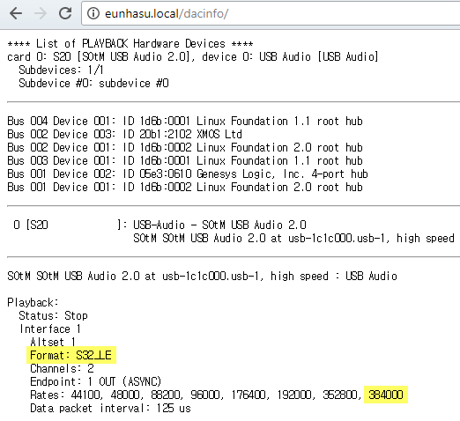
Check your DAC's capability.
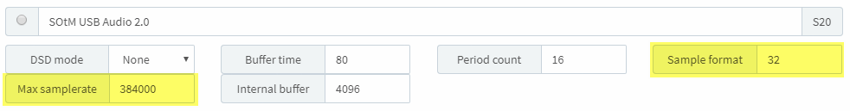
Input 'Max samplerate' and 'Sample format' by DAC information. Please refer to highlighted part.

LMS library rescan guide
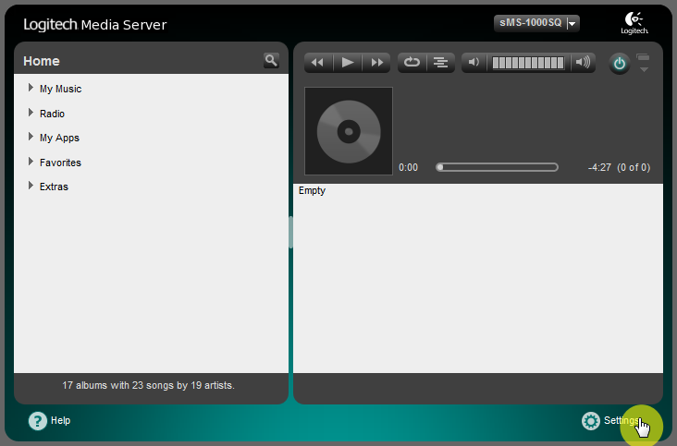
Move on to Settings menu page.
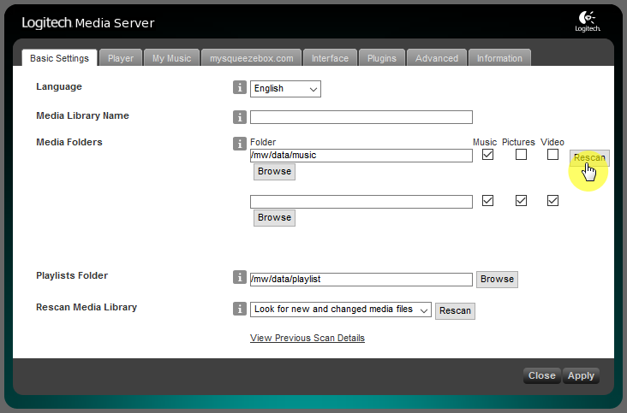
Click “Rescan” button to start scan on Basic Settings tab.
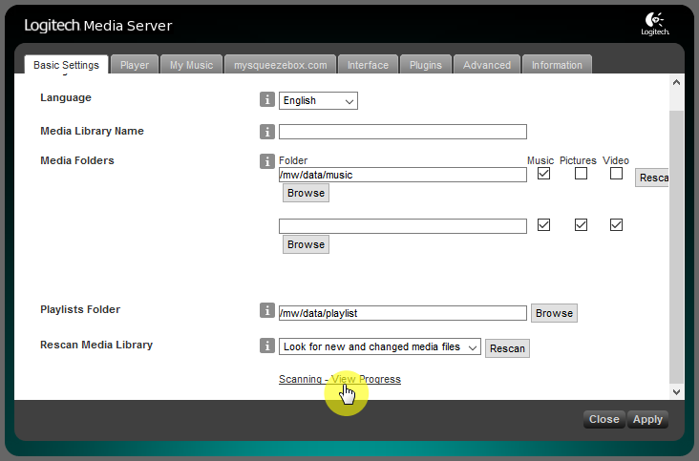
Click “Scanning - View Progress” link at bottom of page if you'd like to see scanning states.
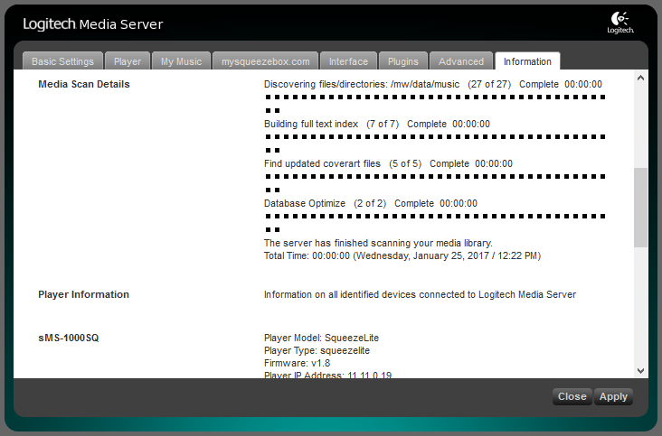
Scanning states screen.

ickStream
ickStream plugin provides lots of third-party feature like Quboz, TIDAL. You can check more information about ickStream in the link,
- http://wiki.ickstream.com/index.php/Open_Beta_Squeezebox_Installation
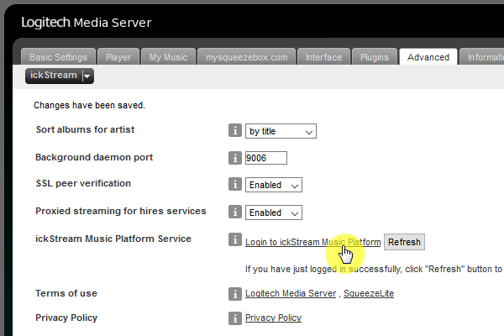
After finishing ickStream plugin installation, you have to agree EULA and login ickStream in LMS > Settings > Advanced > ickStream page.
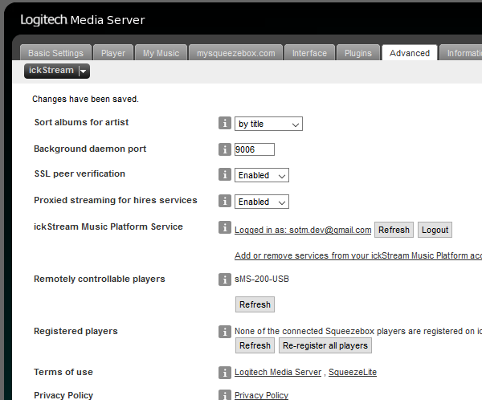
Login complete.
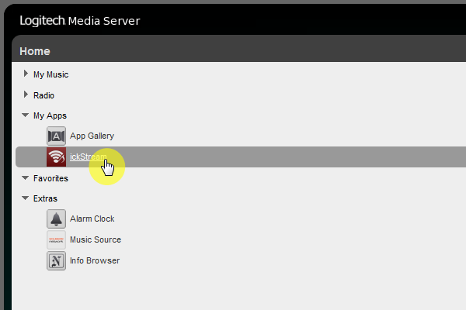
You can see ickStream item in My Apps of LMS main screen.

Video: how to install and set Spotify plugin in LMS; Spotify premium account required.

