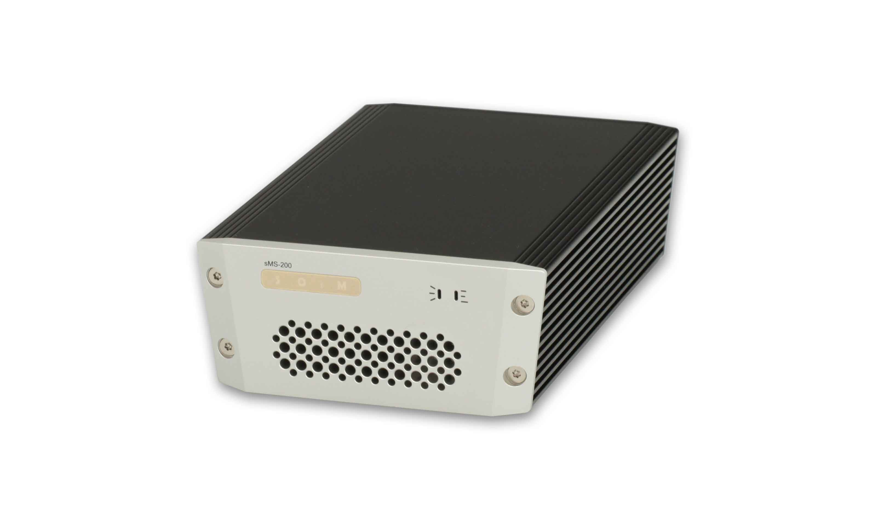

Features
sMS-200 is a compact designed high performance network file player which is capable to share and play music file through network system. It has the following features.
- Web GUI
  - Easy system configuration
  - Selectable music player applications
  - Selectable and configurable USB audio devices
  - Network share folder and USB storage device setting
- Roon Ready
- DLNA audio renderer, OpenHome support
- MPD(Music Player Daemon)
- LMS(Logitech Media Server)
- Squeezelite
- HQPlayer Network Audio Adapter
- Shairport
- Multi-zone network playback
- USB audio output
  - 1 x High-End audio grade USB port
  - 2 x Standard USB ports for USB storage device
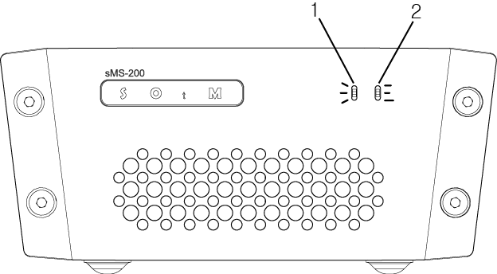
- Power and status indicator lamp: The lamp illuminates when the unit is powered ON and blinks according to its operational status.
- Operating indicator lamp: The lamp blinks according to its operational status.
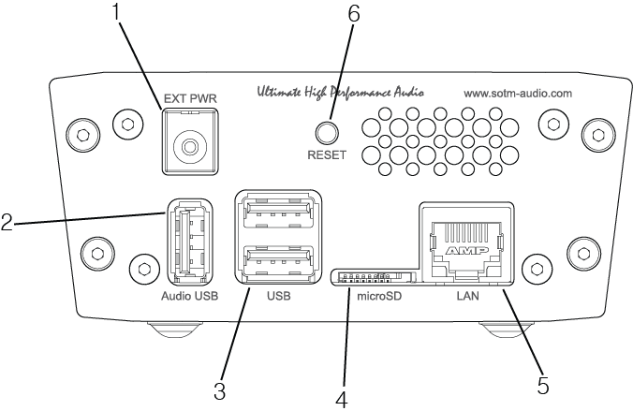
- Power input jack : Connect to a power supply.
- High-End audio grade USB port : Connect to USB audio device.
- USB 2.0 port : Connect to USB storage device.
- microSD card connector : The micro SD card which the product OS is loaded on is inserted.
- Caution: do not pull out the micro SD card while the unit is powered on. Product might be damaged.
- LAN port : Connect to a router by network cable.
- Reset switch : Reset the product by force.

Quick Start
- Installation
  - Take out sMS-200 from the product box and put it on the proper place.
  - The unit should be at least 5 cm(2 inch) away from the wall or other devices.
- Connecting to audio system
  - By USB cable, connect the High-End audio grade USB port on the rear panel of sMS-200 to USB audio device.
- Connecting to network
  - By Ethernet cable, connect the LAN port on the rear panel of sMS-200 to a router.
  - A gigabit speed router and above CAT6 Ethernet cable are highly recommended to make stable network connection.
- Connecting to power
  - Connect to the power input jack on the rear panel of sMS-200 by the power cable from the power supply.
- Preparing the server devices.
  - To use Roon Ready on sM-200, Roon Server should be on the same network.
  - To use DLNA renderer on sMS-200, DLNA server and DLNA control point should be on the same network.
  - To use MPD or Logitech Media Server, connect the USB storage device to the USB 2.0 port on the rear panel of sMS-200 or setup network music folder path on Library config page.
- Power on
  - Connect AC power to the power supply to power on the sMS-200.

How to use Eunhasu Web GUI

Connection
Open the web browser on a PC or smart device and connect to http://eunhasu . On MAC OSX, connect to http://eunhasu.local . You can get Eunhasu device’s IP address or link from http://sotm-audio.com/my if you’re using Android device. If either of above paths would not make connection to Eunhasu Web GUI, check the router setup to find out the IP address of sMS-200. And then enter sMS-200 IP address like http://xxx.xxx.xxx.xxx directly on the browser to connect to Eunhasu Web GUI. If you still couldn’t access the Eunhasu Web GUI, you will need to check network status or power connection is okay. If you connect to Eunhasu Web GUI successfully, you will see the home screen as like the image below.
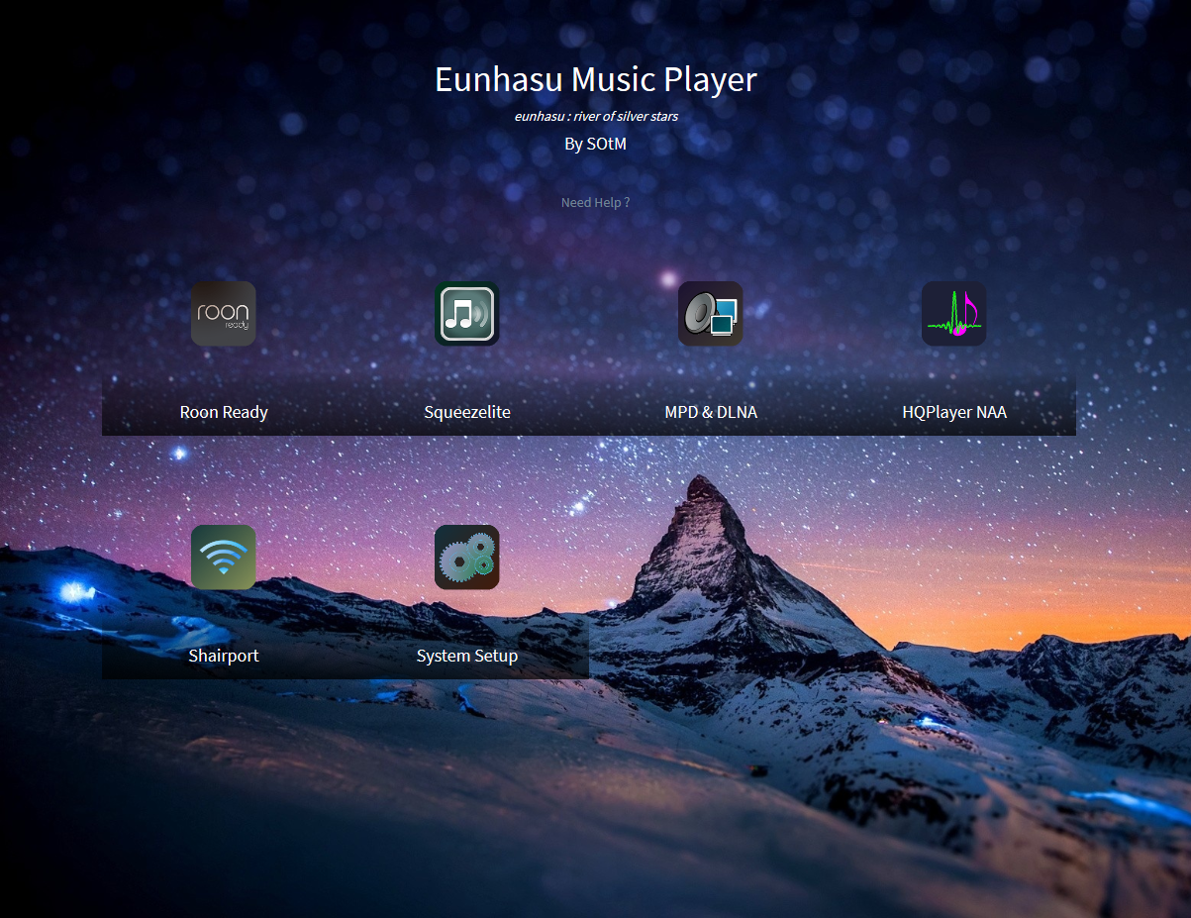 euhnasu home

Select functions
To select the function on the Web GUI, mouse over the desired icon and then action buttons will be appeared. On the smart devices, touch over the desired player icon and then the action buttons will be appeared like when using a mouse.
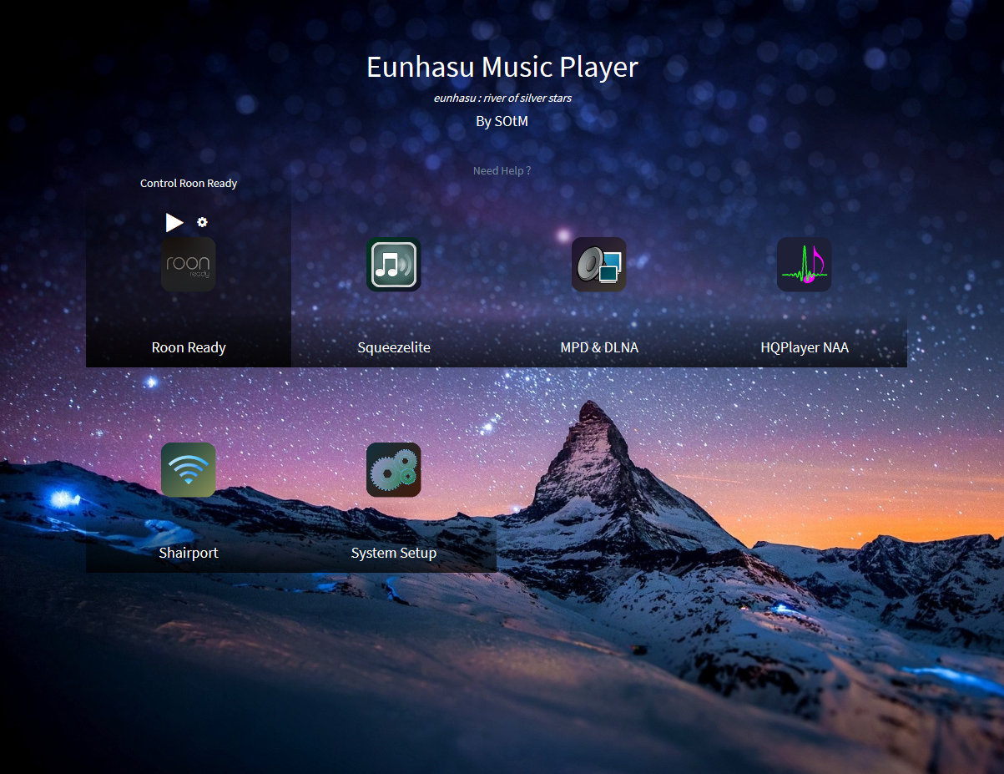 select functions

Roon Ready
Roon Ready is the easy and user friendly network music file player working with Roon Server, it provides the most powerful music playback function. By clicking Play, Stop, Restart or Configuration buttons over the icon, you can control Roon Ready on sMS-200. Please refer to how to use Roon Ready on this manual.

Squeezelite
Squeezelite is a network music file player working with Logitech Media Server, it is integrated with versatile services such as Tidal, Qobuz or internet radios. By clicking Play, Stop, Open LMS web interface, Restart or Configuration buttons over the icon, you can control Squeezelite on sMS-200. Please refer to how to use Squeezelite on this manual.

MPD & DLNA
MPD is a music file player supports playing the music file saved on USB storage device or network share folder. And DLNA is a DLNA audio renderer working with DLNA server and DLNA control point throughout MPD function. It is capable to play music files with various devices like most PC, NAS or smart devices which have the DLNA server function. By clicking Play, Stop, Restart or Configuration buttons over the icon, you can control MPD & DLNA on sMS-200. Please refer to how to use MPD & DLNA on this manual.

HQPlayer NAA

Shairport

System Setup
Network configuration, library configuration, system upgrade, restart and power off functions are available on this icon.

Network Config
Set up the sMS-200 Network configuration.
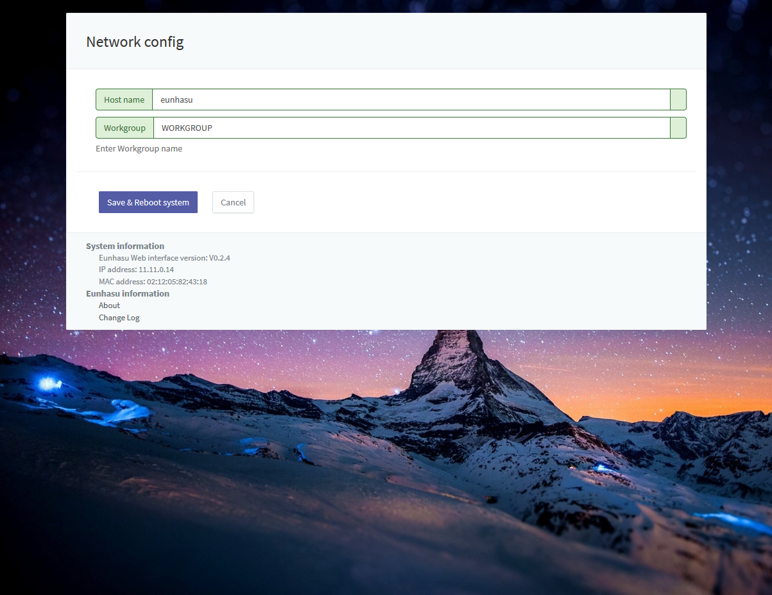 network config
- Host name: A name of sMS-200 appearing on the network. If you use multiple sMS-200s on the network, you will need to use different host name for each sMS-200.
- Workgroup: A workgroup name for share folder on the network, normally “WORKGOUP” is used, but can change if required.
- Save & Reboot system: Save the information and reboot the product
- Cancel: Go back to the home screen.

Library Config
Set up the path for network library and enable the USB storage device to use.
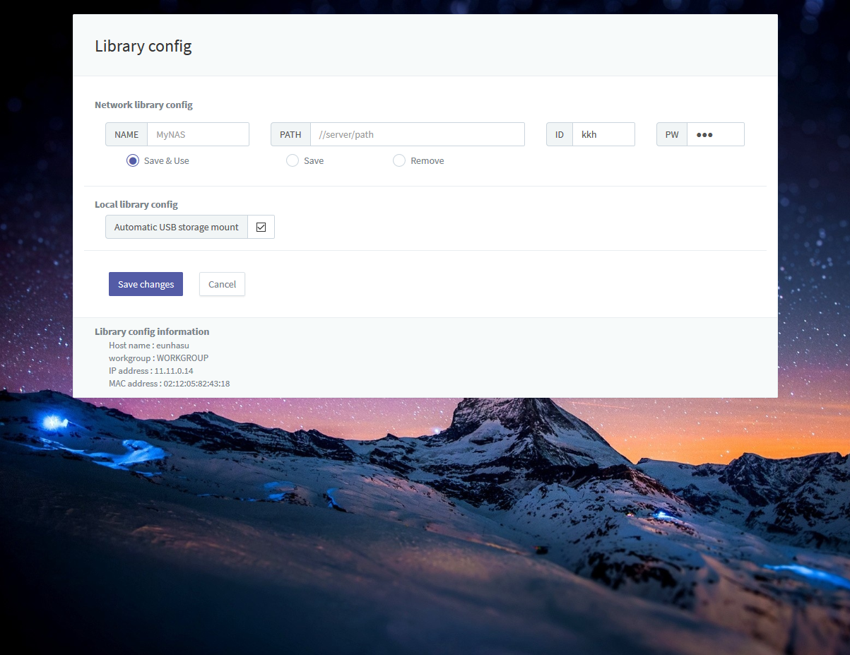 library config
- NAME: A library folder name appearing on Logitech Media Server or MPD.
- PATH: A network sharing folder path. The path should be like following format.
  - //SERVER_NAME_OR_IP/SHARED_FOLDER_NAME
- ID: Enter an ID if it is required to access the network sharing folder.
- PW: Enter a password if it is required to access the network sharing folder.
- Save & Use: Save the information you entered and use.
- Save: Save the information you entered but not in use.
- Remove: Remove the information you entered.
- Automatic USB storage mount: Enable or disable the USB storage device, up to 2 USB storage devices can be used.
- Check 'Automatic USB storage mount' to be enabled, the USB storage device will be auto-recognized and assign music folder on Logitech Media Server or MPD as USB1 or USB2.
- Save changes: Save the new or modified information you entered.
  - NOTE: The new network share folder information can be added after saving the current entered information.
- Cancel: Go back to the home screen.

System Upgrade
Upgrade sMS-200 software.
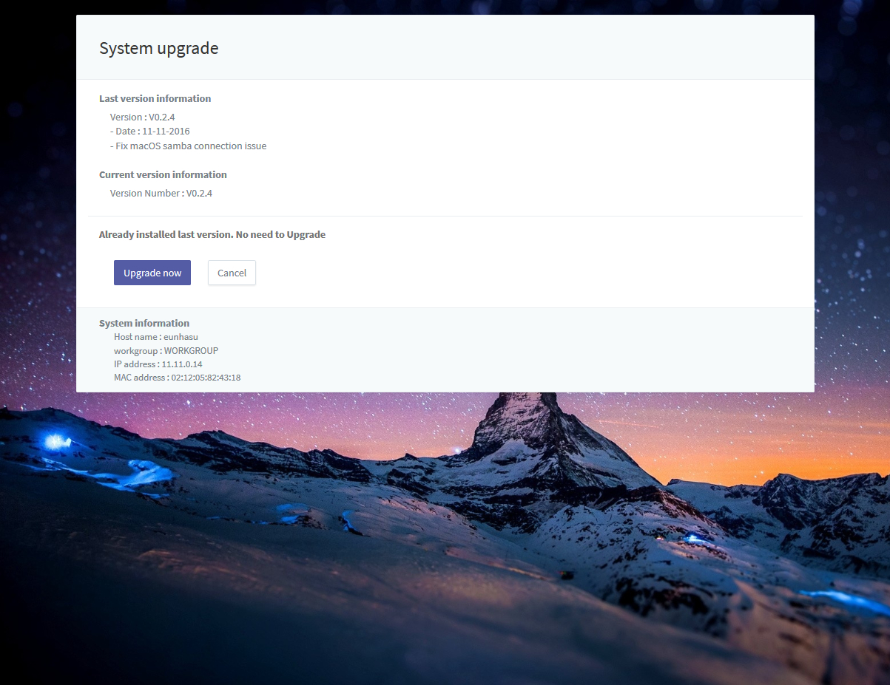 system upgrade
- Last version information: Display the latest software information.
- Current version information: Display the current software information in use.
- Already installed last version. No need to Upgrade: Display whether the upgrade is needed or not by comparing the version of the latest software and current software you are currently using. If the upgrade is needed, it will display as “Upgrade will stop all applications and take a long time”.
- Upgrade now: It stops all program and upgrade the software.
  - CAUTION: The upgrade may require a long time, the power should be on in the mean time upgrading.
- Cancel: Go back to the home screen.
If you have to upgrade mandatory, Eunhasu shows pop-up window to notify.
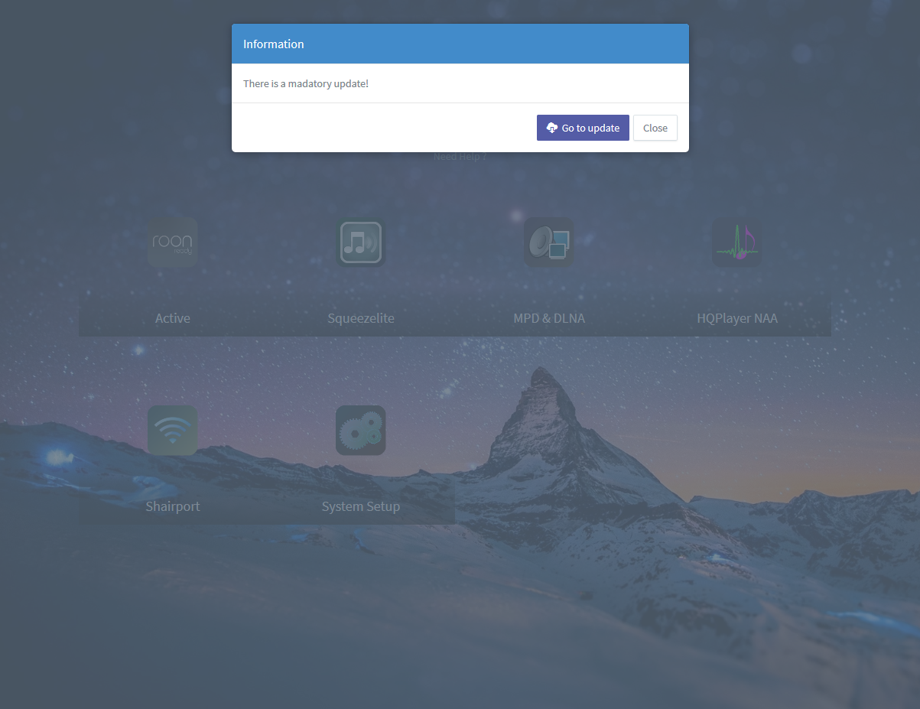 mandatory update

