sMS-200
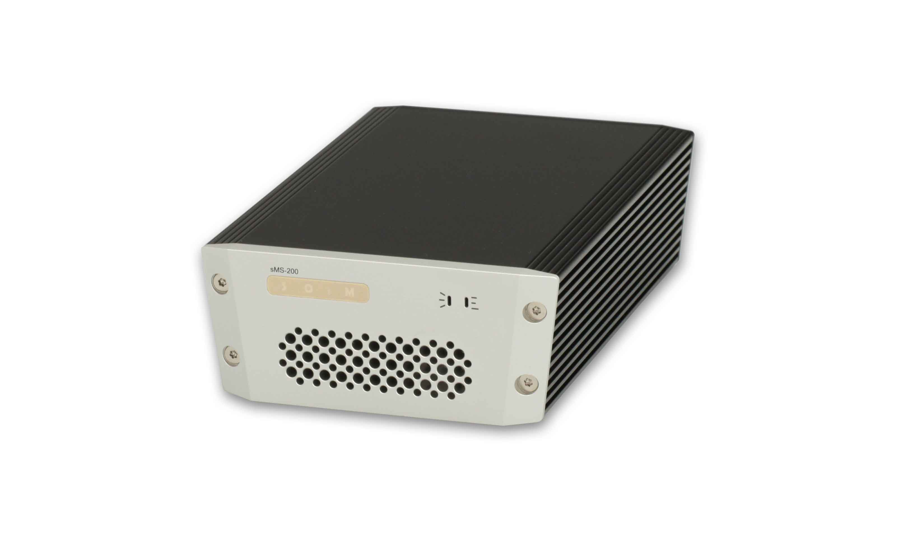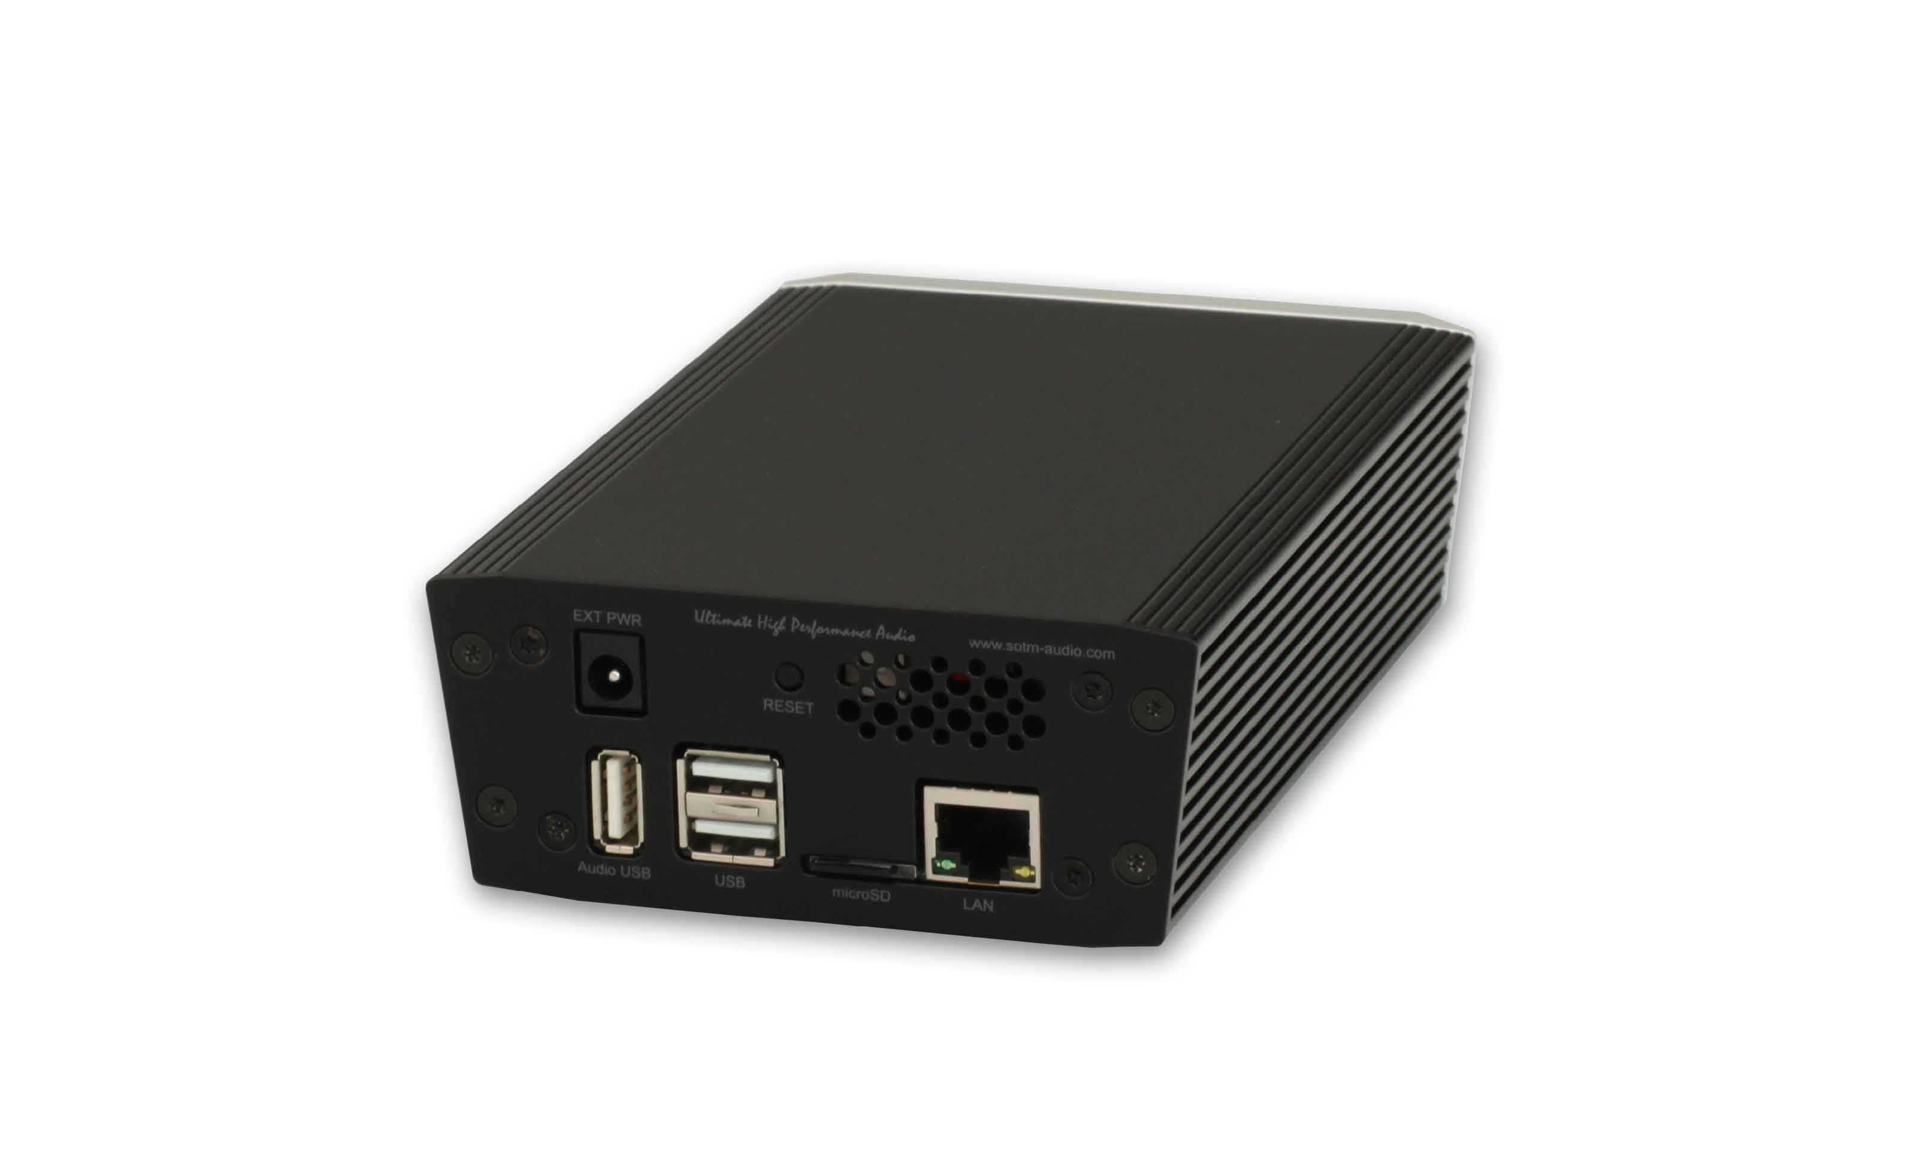

Description
http://www.sotm-audio.com/sotmwp/english/portfolio-item/sms-200/

User Guide
The sMS-200’s formal operating instruction is available here.
sMS-200 is a compact designed high performance network file player which is capable to share and play music file through network system. You can simply set up the multi-room network audio system by connecting a USB audio device to the special USB audio port on the rear panel of sMS-200.
- Roon Ready: Roon Ready is the easy and user friendly network music file player working with Roon Server, it provides the most powerful music playback function.
- Squeezelite: Squeezelite is a network music file player working with Logitech Media Server, it is integrated with versatile services such as Tidal, Qobuz or internet radios.
- MPD & DLNA: MPD is a music file player supports playing the music file saved on USB storage device or network share folder. And DLNA is a DLNA audio renderer working with DLNA server and DLNA control point throughout MPD function. It is capable to play music files with various devices like most PC, NAS or smart devices which have the DLNA server function.

How to use
- Connect a USB audio device to the High-End audio grade USB port on sMS-200 by USB cable.
- Connect a network router to the Ethernet port on sMS-200 by Ethernet cable.
- Check operating status of the server, each server device should operate normally in the local area network. e.g.
  - Roon Ready : The device which is running ROON server should be operated normally in the same local network.
  - SqueezeLite or MPD: connect the USB storage device to the USB 2.0 port on the rear panel of sMS-200 or setup a network music folder path on Library config page.
  - DLNA : connect sMS-200 to a DLNA server by a DLNA control point.
- Turn on sMS-200 by connecting the correct power supply to POWER IN jack on the rear panel of sMS-200.
- Wait around less 30 seconds until the sMS-200 boot process is completed and then type http://eunhasu/ or its own IP address on a web browser to connect sMS-200 web page. (type eunhasu.local on iOS device)
- Once connected sMS-200 Web Page, Eunhasu, select one of audio function icons which you wish to use.
- Touch or mouse over one of audio function icons, you will see there are action buttons () available.
- Click ‘Start’ button to make the function activated and it will need around less 10 seconds to be applied and then ‘Active’ sign will be shown under the icon.
- If you want to change the audio function, click ‘Stop’ button on the current audio function and change the audio function using the above procedure.
- To turn off the sMS-200, click the System power off button on the System setup icon.

Video clip

Roon ready on sMS-200

Squeezelite on sMS-200

HQplayer on sMS-200

