MPD / DLNA renderer
MPD is a high performance music playback service that can play music files on a USB storage device or network share folder. Eunhasu has only DLNA audio renderer not include other DLNA stack. You can use Eunhasu with a DLNA server. However, sMS-1000SQ Eunhasu product has a DLNA server feature which is MinimServer. You could use 'MPD / DLNA renderer' with MinimServer if you have sMS-1000SQ Eunhasu.
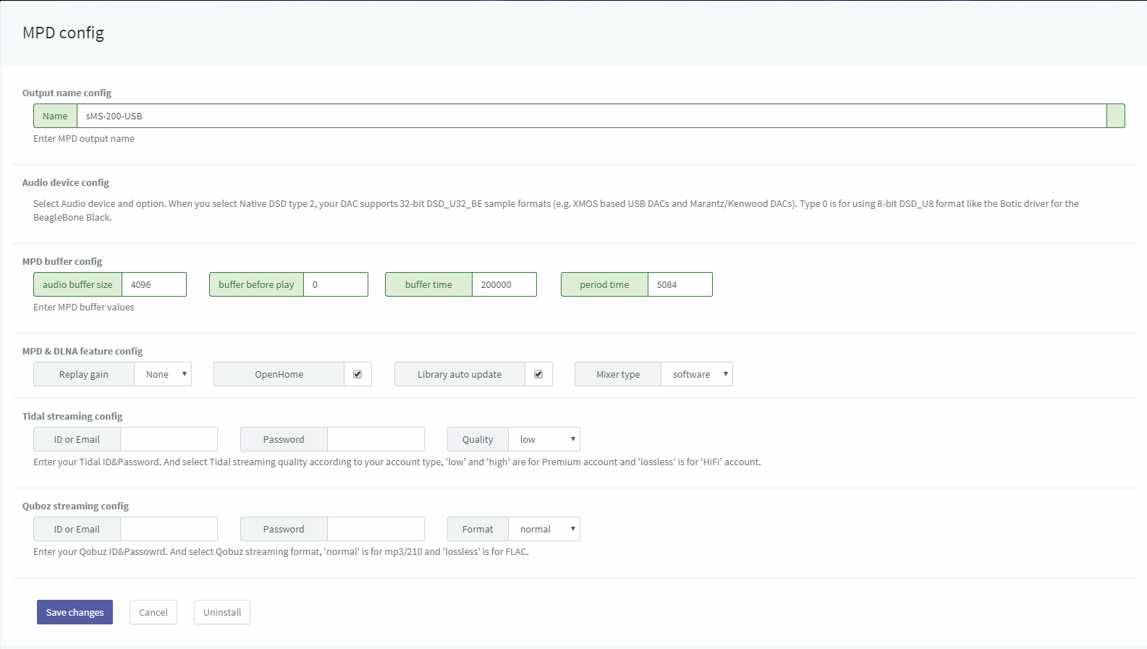full
- Name: A name of Eunhasu's MPD & DLNA appearing on MPD controlling App and DLNA controlling App. This can be changed if you need.
- Audio device config: Select a radio button of USB DAC which is going to use and click 'Save changes' to use the USB DAC.
- DOP enable: Check for using DOP function while playing DSD music file.
- Native DSD type 0: To use 8-bit DSD_U8 format DAC. (e.g. BeagleBone Black using Botic driver)
- Native DSD type 2: To use 32-bit DSD_U32_BE format DAC. (e.g. XMOS-based USB DACs or Marantz/Kenwood DAC)
- Replay gain: Choose Replay gain among None, Album or Track.
- OpenHome DLNA Renderer: Check for using OpenHome DLNA Renderer feature.
- Library auto update: Check for auto-scanning and updating the library.
- MPD Buffer config: Adjust the buffer value according to your environment.
  - Audio buffer size: Specifies the size of the audio buffer in Kbytes.
  - Buffer before play: Specifies the amount of audio buffer that must be filled before playing the song. Increase this value if there is a break in the sound source when the song moves to the next song. Only numbers between 0 and 100 can be entered.
  - Buffer time: Sets the buffer length of the sound source data to be sent to the audio device in microseconds.
  - Period time: Sets the transmission interval of sound source data to be transmitted to the audio device in microseconds.
Detailed information about each item of Buffer config can be confirmed at the following URL. https://linux.die.net/man/5/mpd.conf
- Tidal streaming config: This setting is for users who use Tidal streaming with mpd / dlna. Enter your Tidal account information to be used in the ID and Password fields, and set the quality according to the Tidal rating you use. Low / high quality is available for premium-grade accounts, and lossless quality is available for HIFI ratings.
- Qobuz streaming config: This is for users who use Qobuz streaming with mpd / dlna. Enter the Qobuz account information to use in the ID and Password fields, and set the format according to the Qobuz rating you use. The nomal rating is capable of playing mp3 sound sources, and lossless is capable of playing FLAC sound sources.
Native DSD feature is available from Eunhasu V0.3.2.

MPD clients
- MPDroid: https://play.google.com/store/apps/details?id=com.namelessdev.mpdroid
- M.A.L.P. - MPD Client: https://play.google.com/store/apps/details?id=org.gateshipone.malp
- MPod: https://itunes.apple.com/kr/app/mpod/id285063020?mt=8 out of dated
- MPDluxe: https://itunes.apple.com/us/app/mpdluxe/id991758069?mt=8
- Gnome Music Player Client: https://gmpclient.org/installation
- Chimney: https://www.microsoft.com/en-us/store/p/chimney/9wzdncrfj6jx
Reference: http://mpd.wikia.com/wiki/Clients

how to connect and access NAS in sMS-200
How to connect NAS to Squeezelite or MPD/DLNA on sMS-200

Last Updated:

