MinimServer
MinimServer is one of the best UPnP Audio Server. MinimServer collects user's music and is operated by a DLNA control point such as Bubble UPNP app. You can search and playback your music files more conveniently.
MinimServer should be installed by the user. Installation is available in the MinimServer config page.
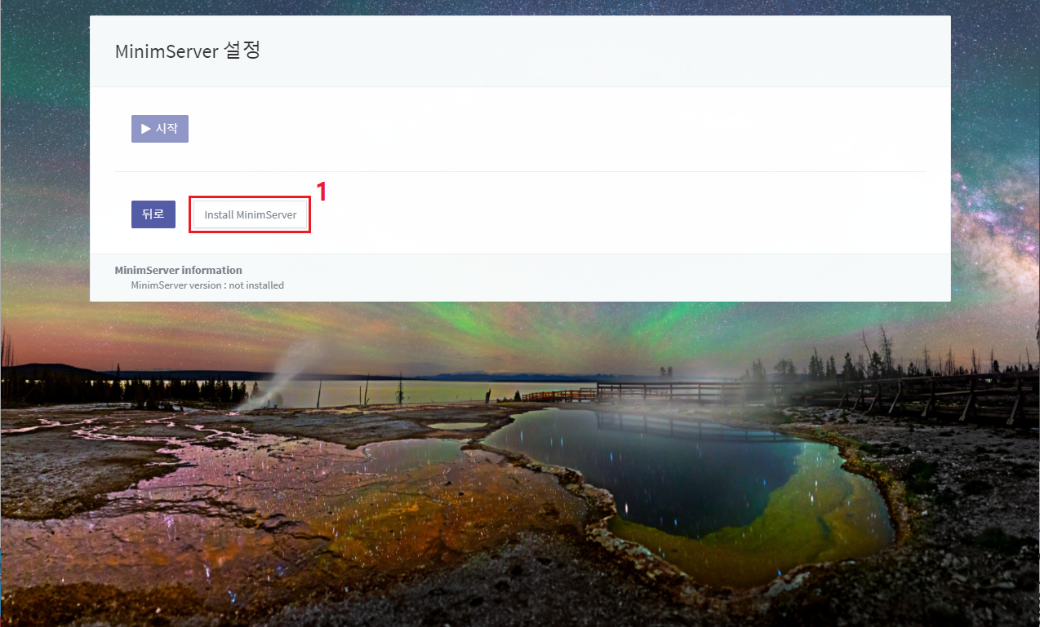
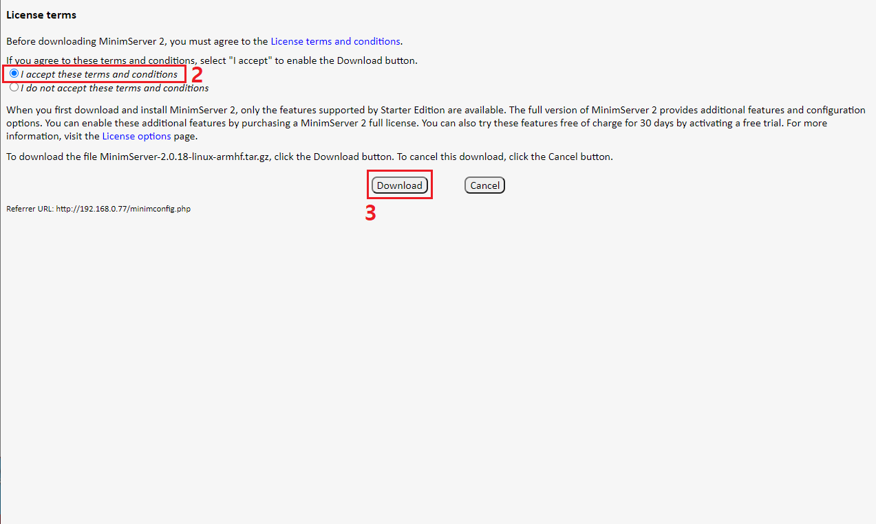
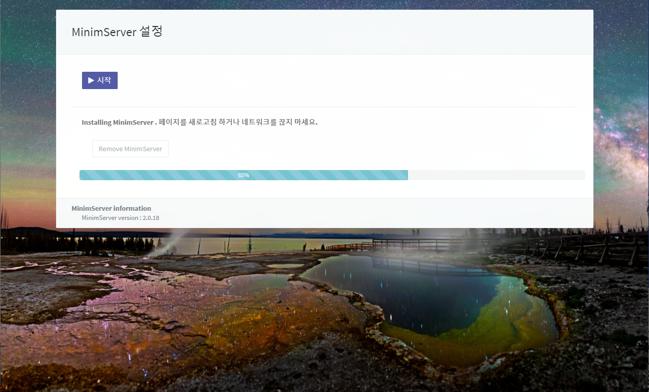
MinimServer can be controlled in the MinimServer config page, start, open, stop or restart after the installation is done.
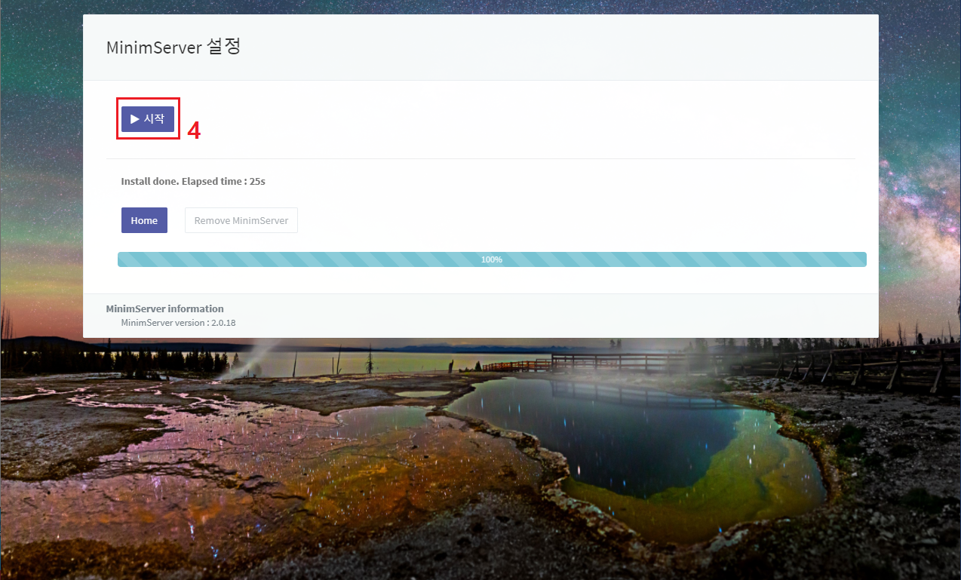
Content directory of MinimServer setting has to be set in MinimServer config page which could be opened after starting MinimServer.
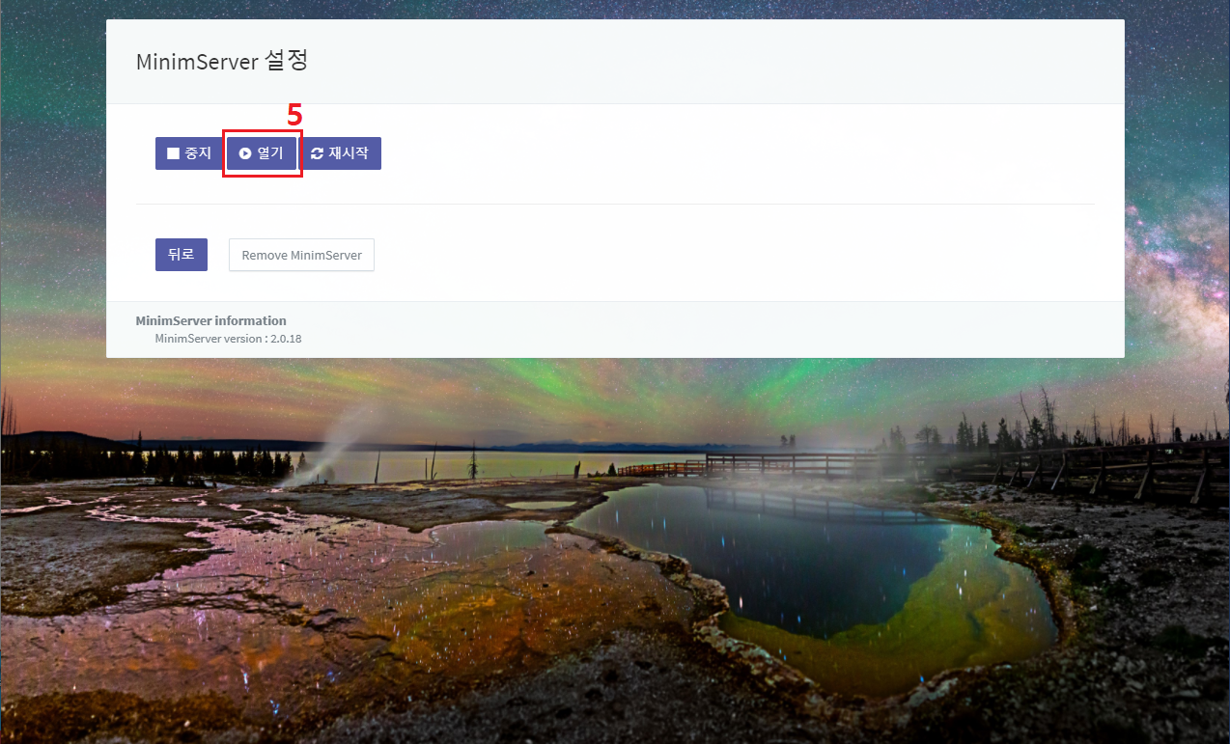
First, you have to accept MinimServer license terms to use.
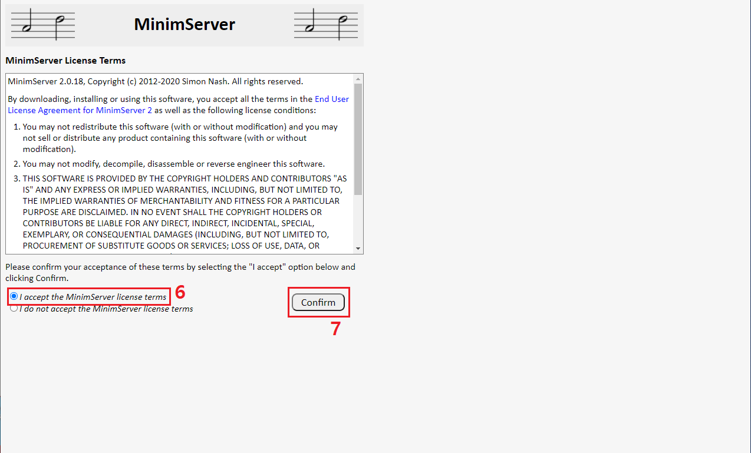
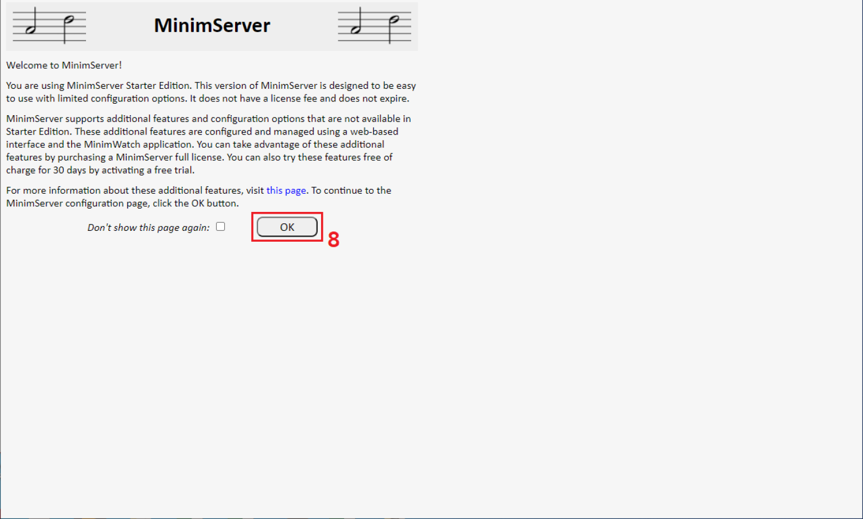
Set Content directory and press 'Update' button and press 'Rescan' button.
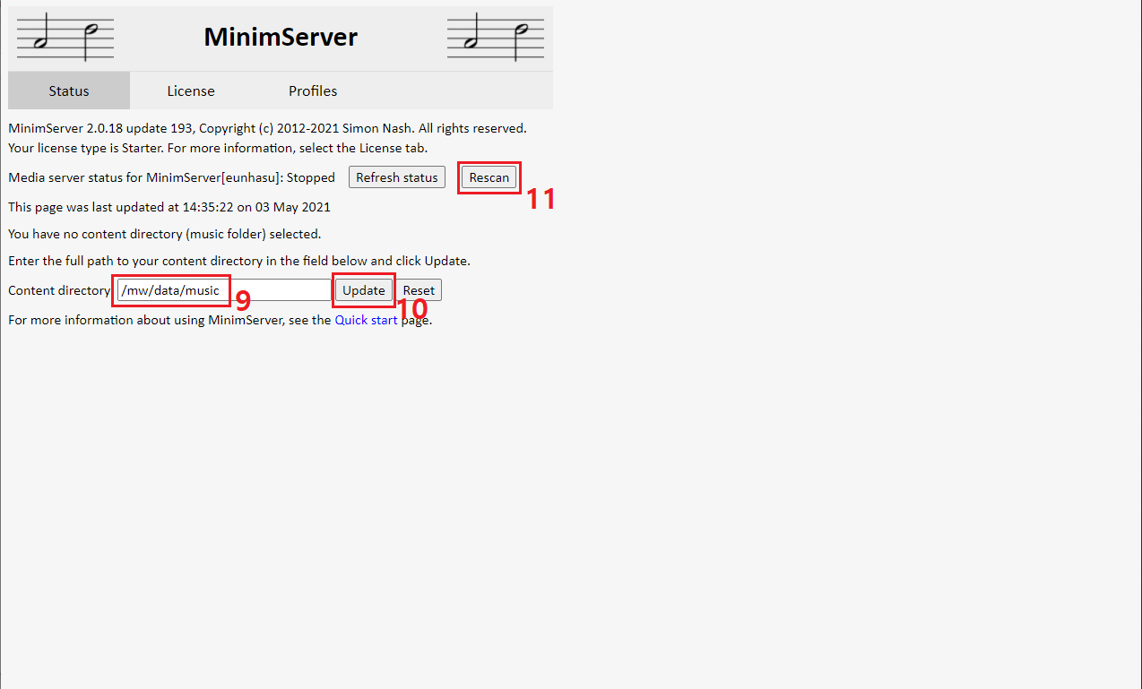
- Content directory shoule be /mw/data/music to collect music in Eunhasu system.
- If /mw/data/music space are 100% full, the main system would be in abnormal status and not be operating normally.

Last Updated:

