LibreSpot
LibreSpot is a open source implementation for Spotify-connect® which is served from Spotify®.
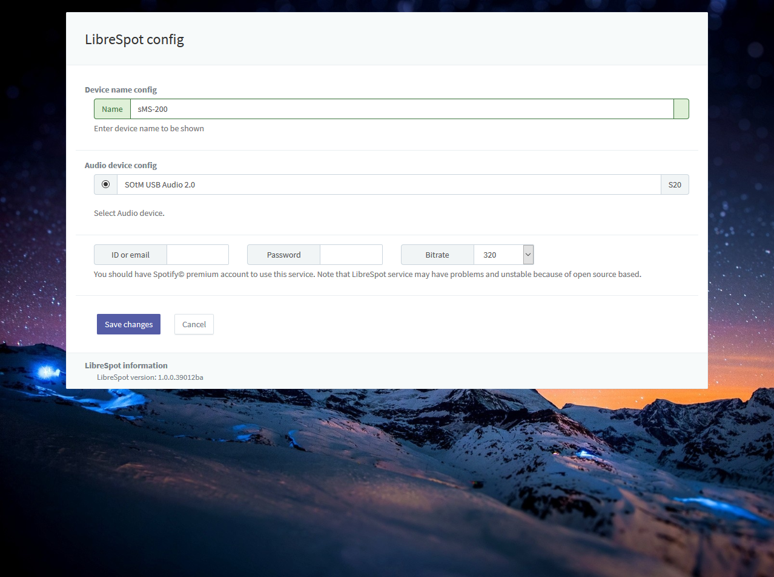
LibreSpot requires Spotify© premium account to use. Note that LibreSpot service may have problems and be unstable because of the open source based service.

