How to make direct connection between sMS device and Windows system.
Download tftpd32 and install it.
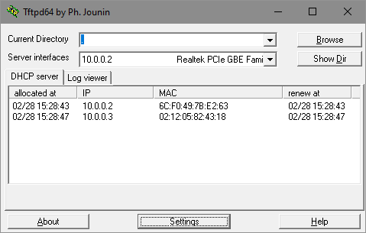
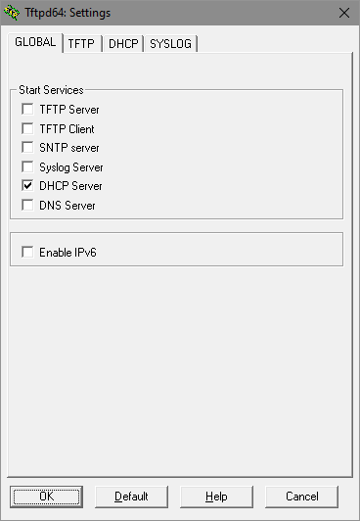
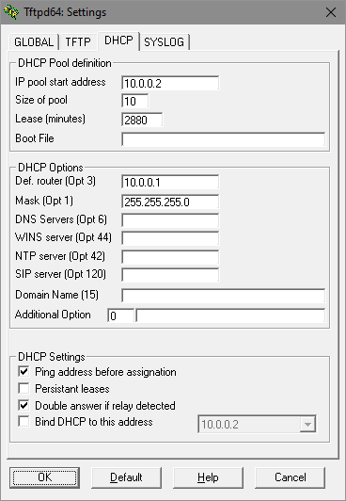
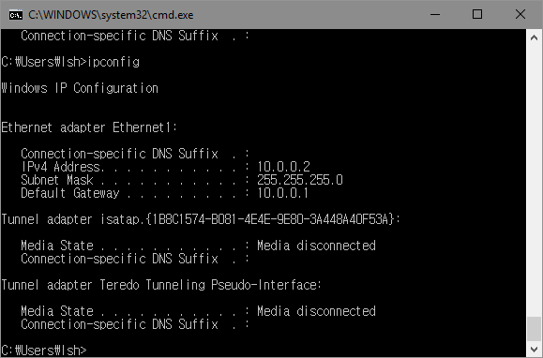
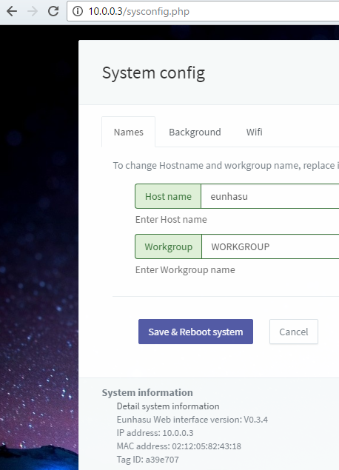
Example setting to enable DHCP server on you windows system: Click a button named 'Settings' Select DHCP server Set configurations like my example or what you want Windows result sMS-200 result of dynamic IP allocation

