HQPlayer NAA
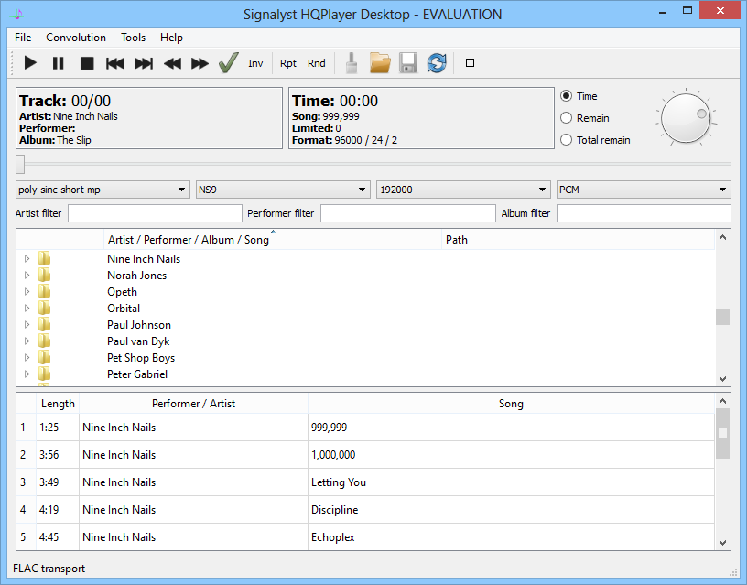
HQPlayer Desktop is high performance media player to be able upsampling on Windows, macOS and Linux. HQPlayer NAA is a kind of media bridge between HQPlayer Desktop and device via local network. Especially, NAA is a superb for DSD playback.
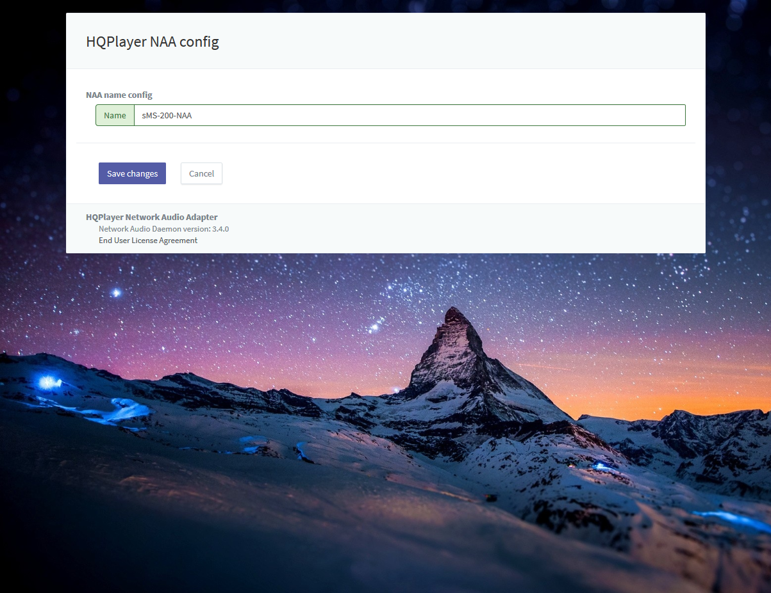
You can change device name for HQPlayer Desktop in Eunhasu's HQPlayer NAA config page.
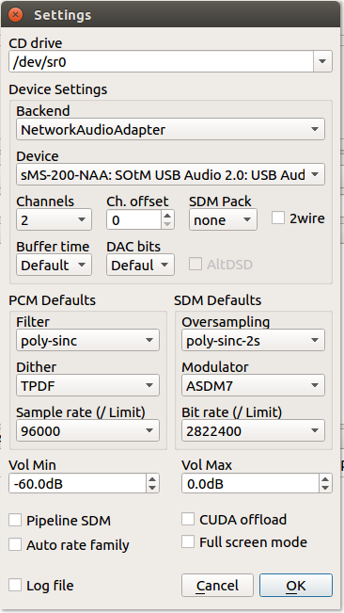
This screen shot is from HQPlayer Desktop settings menu, you can see a name of NAA device.

simple demo video

Last Updated:

