Requirement
- sMS-200 V0.3.0 above or sMS-1000SQ Eunhasu V0.3.0 above
- a Wifi dongle
  - a Wifi dongle which uses a RTL8811AU, RTL8812AU, RTL8812A, RTL8821A or RTL8814A, RTL88x2BU, RTL8821AU, RTL8821CU, RTL8814AU chipset.

Simple Instruction
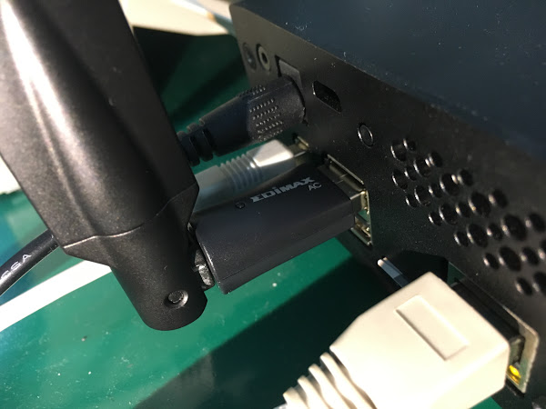
Connect a Wifi USB dongle into on of the two USB port. To setup Wifi feature on Eunhasu, the wired LAN should be connected.
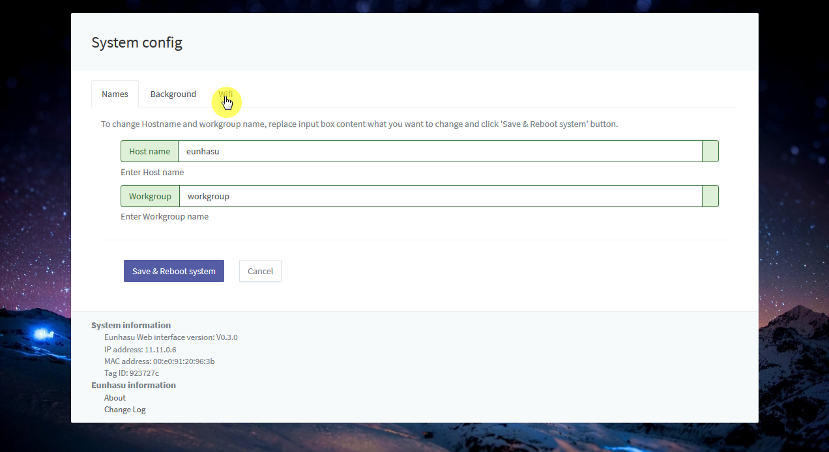
Click 'Wifi' tab in System config page.
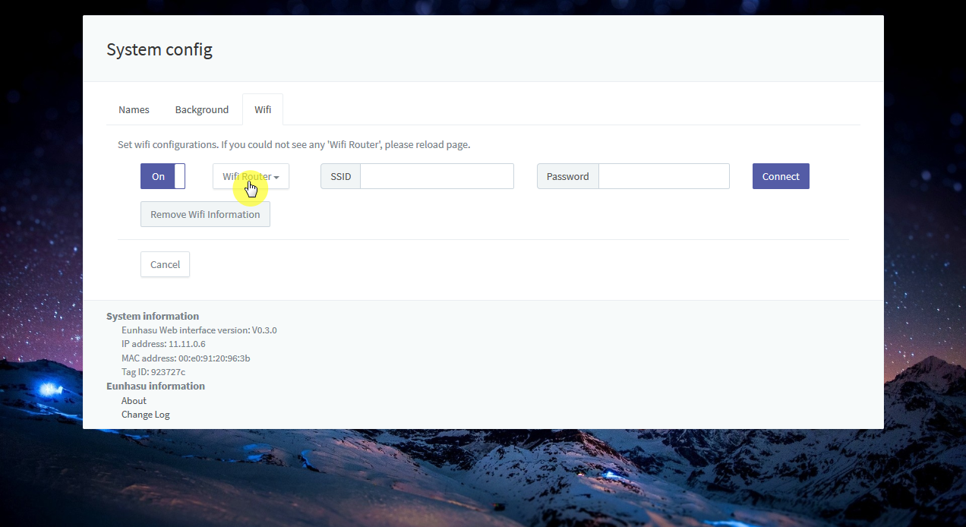
Click 'Wifi Router' button to show Wireless Access Point and it will take a few minutes to be detected the AP.
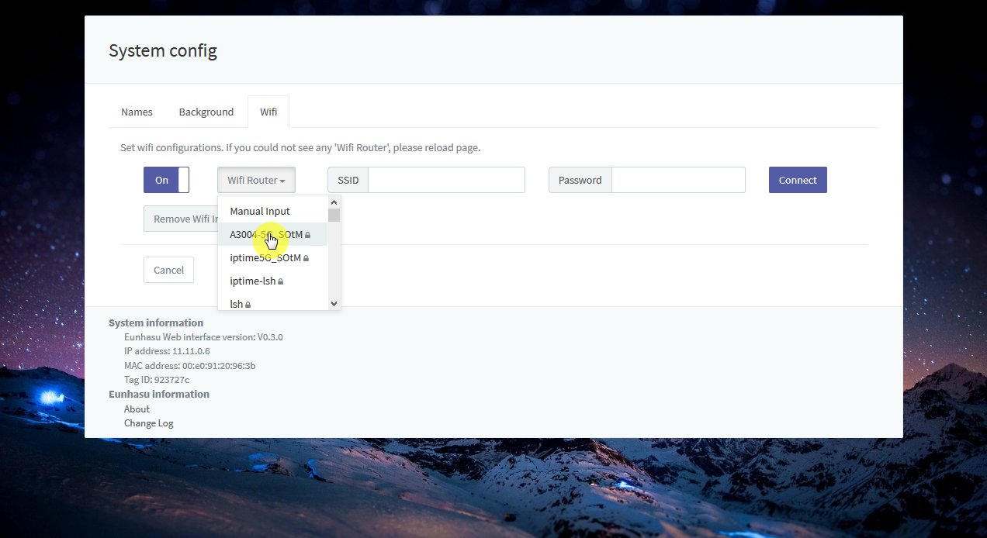
Select AP what you want.
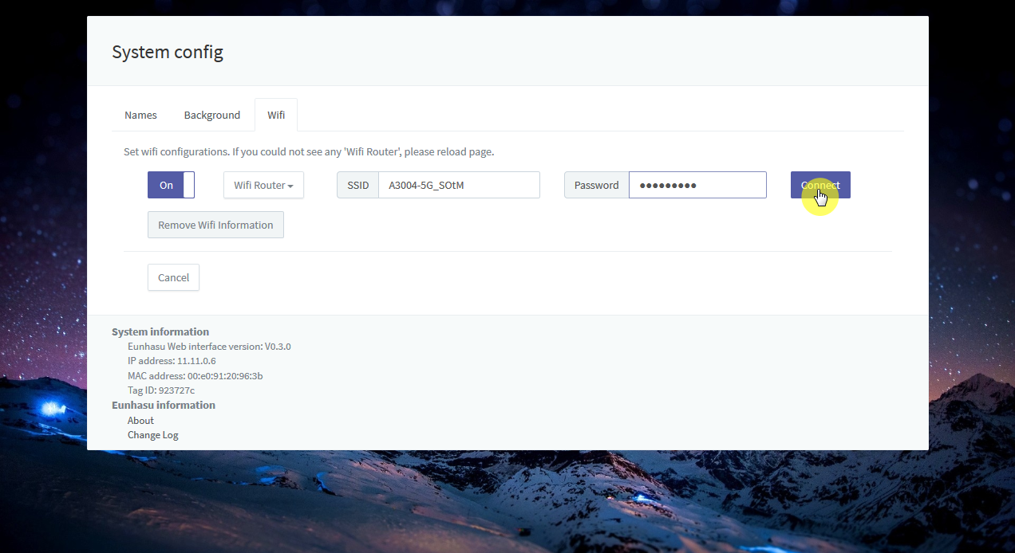
Enter password or secret if required.
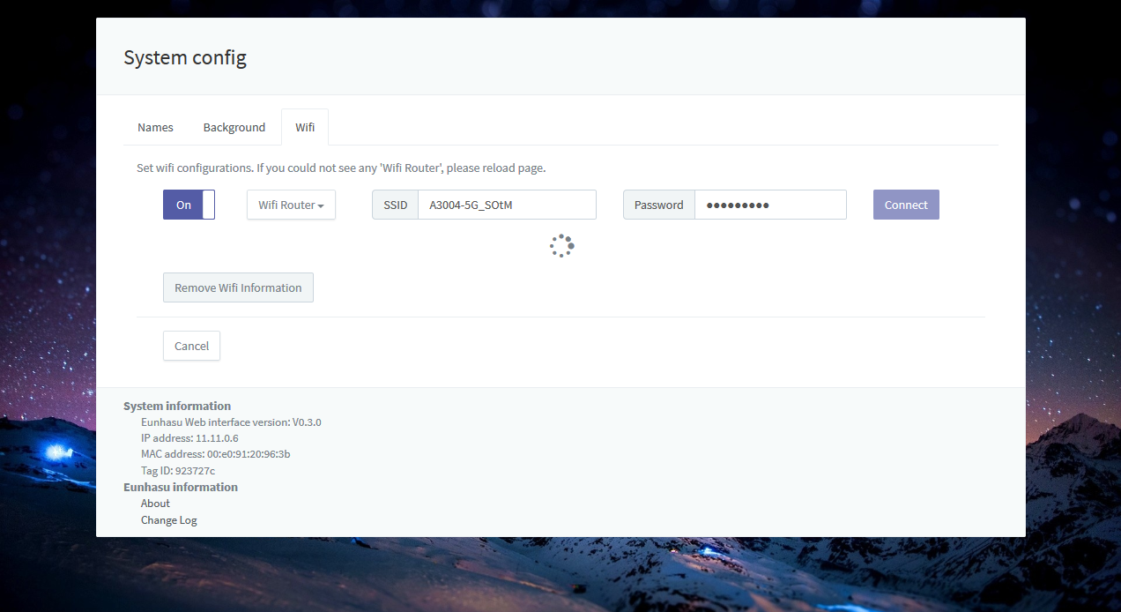
Wait till the progress will be done.
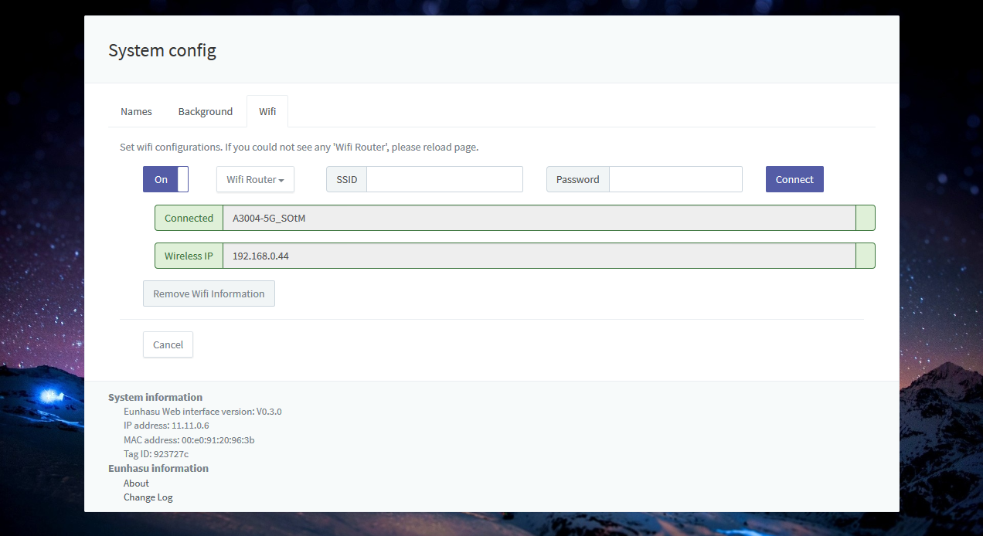
After connecting successfully, you can see IP address like the screen shot below.
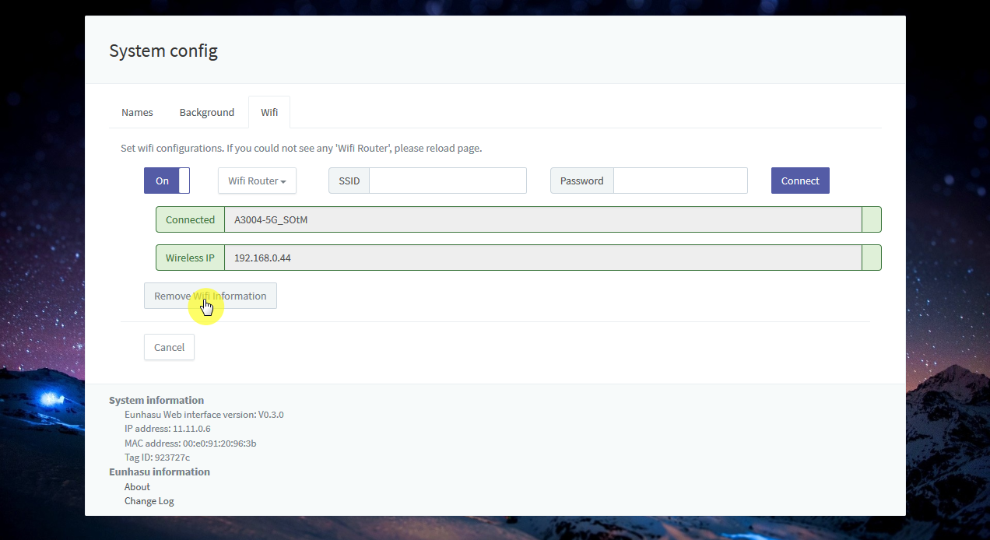
If you need to remove the Wifi connection information, Click 'Remove Wifi Information' button, it will remove all saved information including the name and password.
- Eunhasu version >= V0.3.0 is required.
- There might be connection error if you use wired and wireless network at the same time.
- Network speed could be degraded depends on wireless network status.
- After connected wireless, use the IP address to be connected.

Reference

Video clip

Device IDs in driver
- 0x050D, 0x1106 : Belkin - sercomm
- 0x050D, 0x1109 : Belkin F9L1109 - SerComm
- 0x2001, 0x330E : D-Link - ALPHA
- 0x7392, 0xA822 : Edimax - Edimax
- 0x0DF6, 0x0074 : Sitecom - Edimax
- 0x04BB, 0x0952 : I-O DATA - Edimax
- 0x0789, 0x016E : Logitec - Edimax
- 0x0409, 0x0408 : NEC -
- 0x0B05, 0x17D2 : ASUS - Edimax
- 0x0E66, 0x0022 : HAWKING - Edimax
- 0x0586, 0x3426 : ZyXEL -
- 0x2001, 0x3313 : D-Link - ALPHA
- 0x1058, 0x0632 : WD - Cybertan*/
- 0x13B1, 0x003F : Linksys WUSB6300
- 0x1740, 0x0100 : EnGenius - EnGenius
- 0x2019, 0xAB30 : Planex - Abocom
- 0x07B8, 0x8812 : Abocom - Abocom
- 0x2001, 0x3315 : D-Link - Cameo
- 0x2001, 0x3316 : D-Link - Cameo
- 0x20F4, 0x805B : TRENDnet - Cameo
- 0x2357, 0x0101 : TP-Link - Archer T4U
- 0x2357, 0x0103 : TP-Link - T4UH
- 0x2357, 0x010D : TP-Link - Archer T4U AC1300
- 0x2357, 0x010F : TP-Link - Archer T4UHP
- 0x148F, 0x9097 : Amped Wireless ACA1

Last Updated:

