- This instruction is about to upgrade both sDP-1000EX's Main firmware and Audio USB module firmware.
- The both firmware upgrade should be done at once.

How to upgrade the Main Firmware of sDP-1000EX

Preparations
- Download sDP-1000EX's Main firmware.
sDP-1000Ex_V2.0a_20190607.hex
- Download and install Flip software for the firmware upgrade.
Flip 3.4.7 software

Connect to sDP-1000EX
Connect sDP-1000EX to PC by a USB cable. Change the position of the red switch on the rear panel of sDP-1000EX to the DFU side. The red switch is next to Audio USB port. Turn on sDP-1000EX. The OLED won't display anything.
- If, the OLED displays something, check the red switch's position, and then try to turn on the device again.
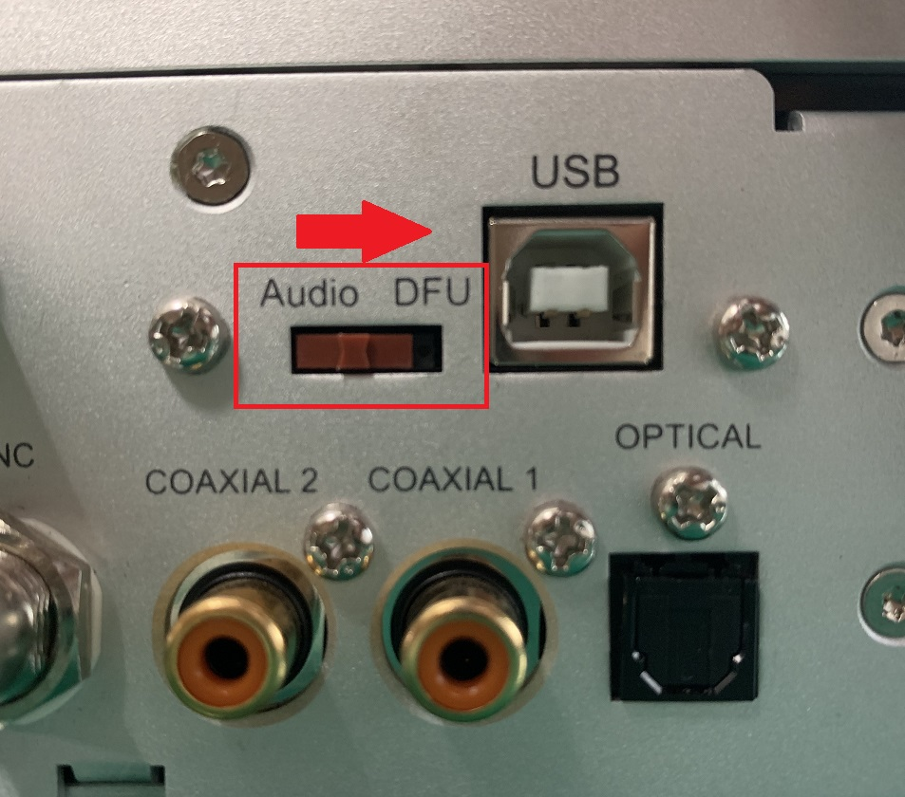

Run Flip program
Run Flip program. 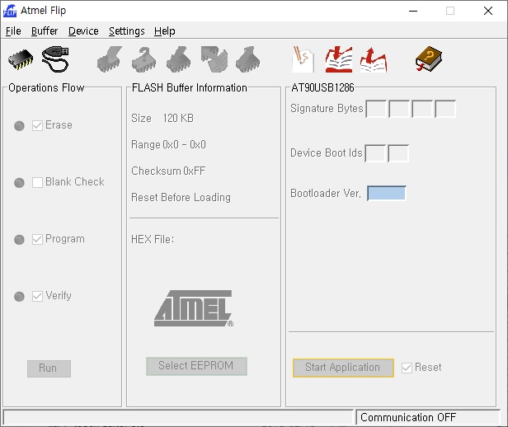

Select a device
Click the button to select a device, and select AT90USB1286. 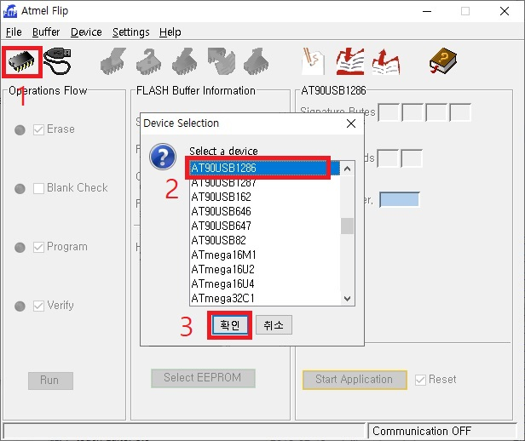

Connect the device
Select USB Port Connection and click Open button to be connected. 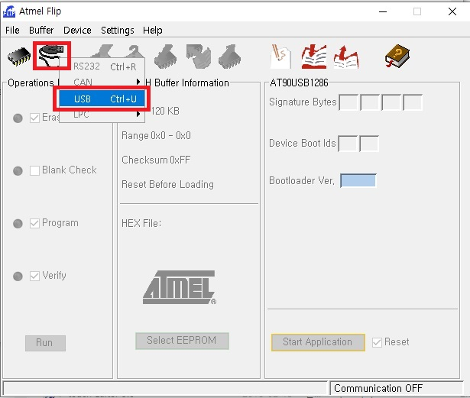 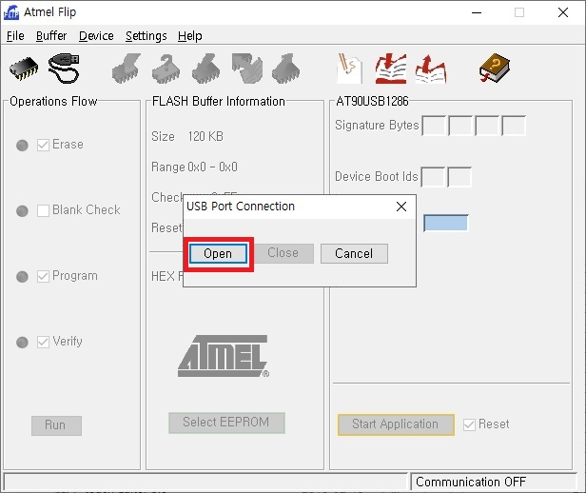

Select Firmware file
Select Load Hex File mene , and then select the download firmware. 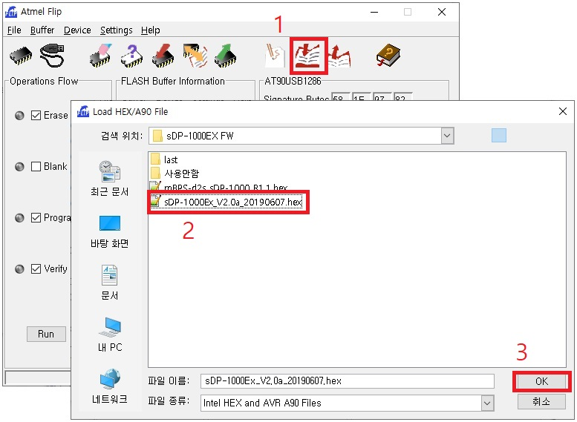

Update Firmware
Click 'Run' button to update the firmware. 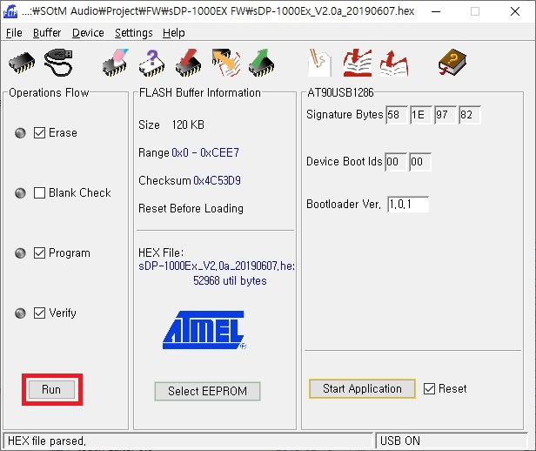

Finish upgrading the main firmware
Once the main firmware upgrade is finished, change the position of the red switch to Audio side, and turn on the device. Then, the OLED display normally.
- If, the OLED display nothing, check the position of the red switch again, then power on the device.
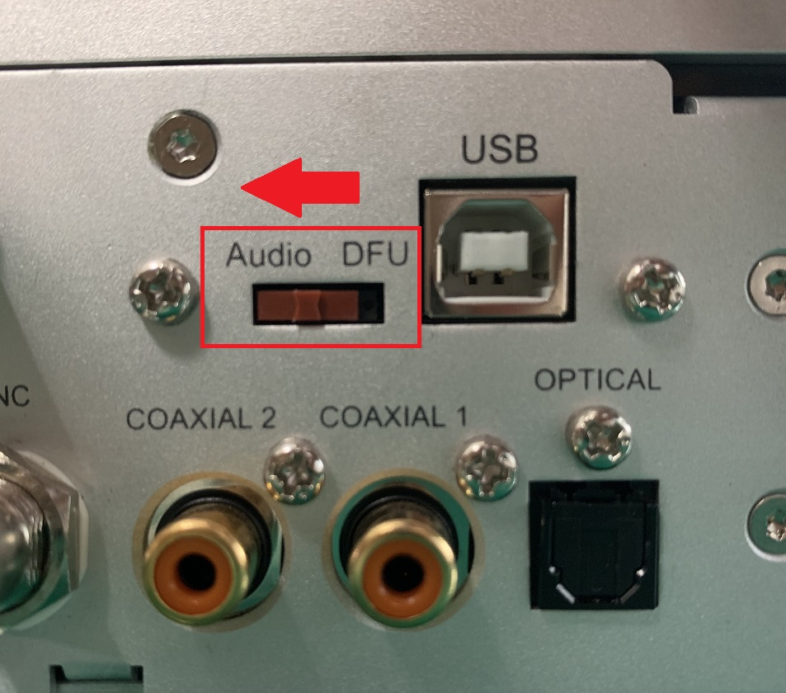

Upgrade Audio USB module firmware

Preparation
- Download the Audio USB module firmware.
sDP-1000EX_USB_V6.C1_20190604.bin
- If the SOtM driver for Windows OS is not installed, download and install it to the PC properly.
SOtM USB Audio 2.0 Driver v2.23.0

Upgrade SOtM USB Audio Firmware
- Connect sDP-1000EX to PC by a USB cable, and turn on the sDP-1000EX.
- Run SOtM USB Audio Firmware Upgrade.
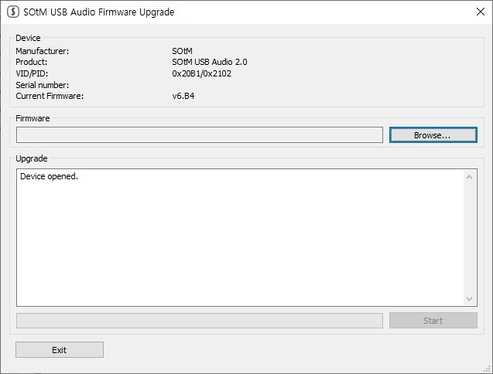

Select the firmware file
Click Browse button and select the downloaded firmware. 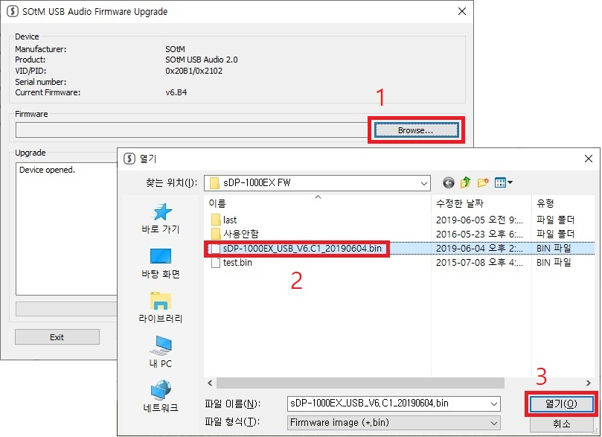

Update the firmware
Click Start button to update the firmware. 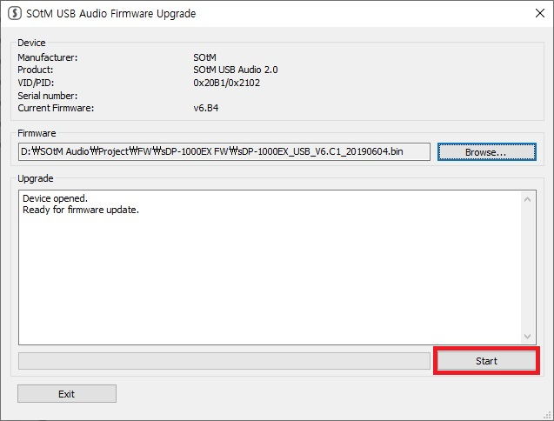

Finish upgrading the USB audio firmware
Run SOtM USB Audio Control Panel and check the firmwre version of sDP-1000EX.
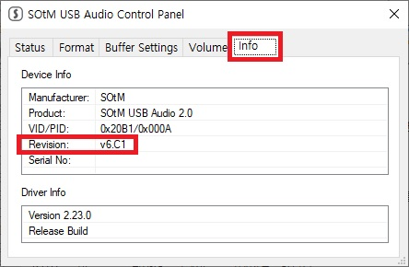

Download

sDP-1000EX FW file
- sDP-1000Ex_V2.0a_20190607.hex
- sDP-1000EX_USB_V6.C1_20190604.bin

Utilities
- Flip 3.4.7 software
- SOtM USB Audio 2.0 Driver v2.23.0

