mBPS-d2s Battery Replacement Manual
CAUTION
- If circumstances allow, ask replacement to distributor or retail shop.
- Be careful not to overtighten screws.
- Please recycle your used batteries that have explosion risk
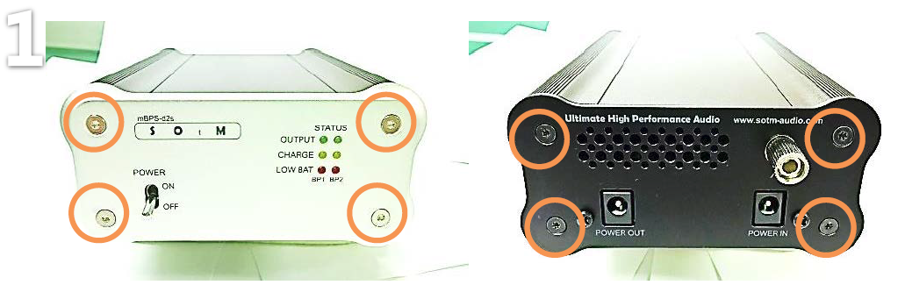
Remove eight Torx screws carefully
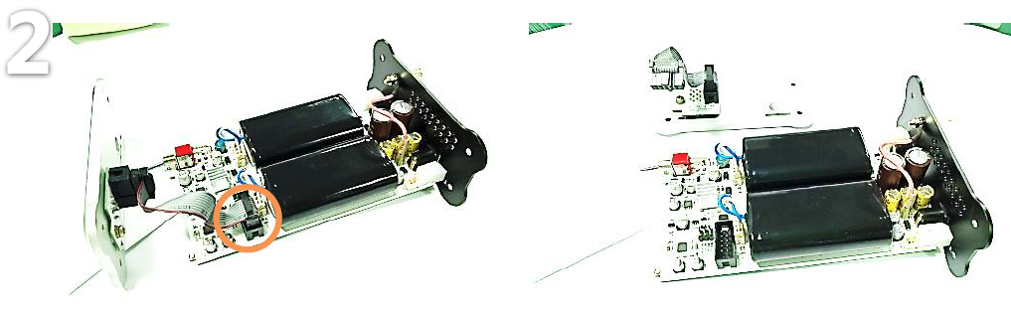
Remove the LED ribbon cable by pulling down
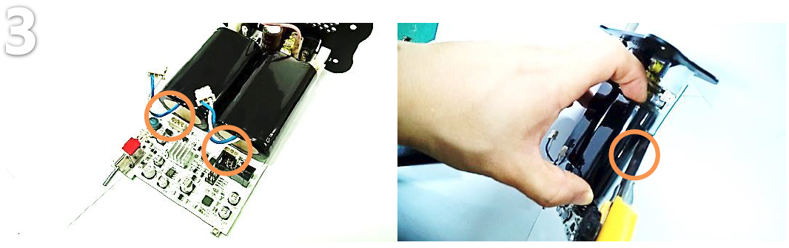
- Remove the two connectors which are placed in front of the batteries by pulling down
- Pry the battery packs off the back plate carefully by using tools such as straight razor
- Remove residual tape on the back-plate
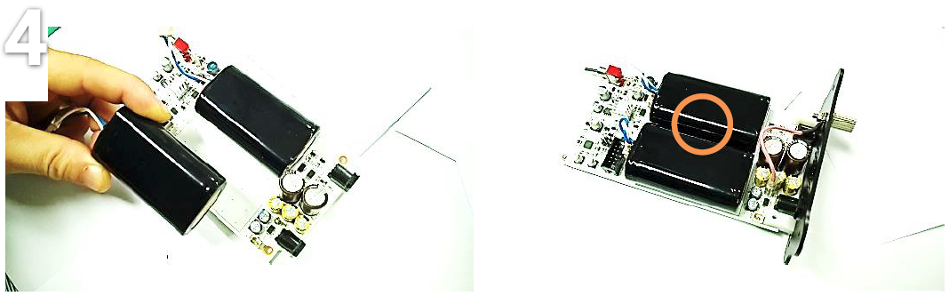
Remove backing on the two way tape from the new battery; center carefully on the board and make a little space between two batteries
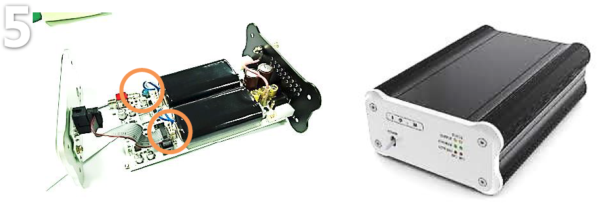
Plug the battery terminals in, and then screw every plates to complete replacement

