Download
Download dX-USB HD windows driver file from http://www.sotm-audio.com/sotmwp/english/portfolio-item/dx-usb-hd/

Install
Unzip downloaded file and run setup.exe
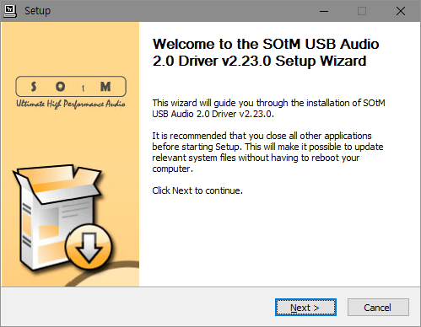
Please click “Next” button to proceed the next steps
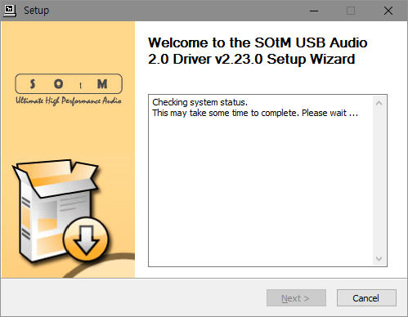
Checking system status. Please connect the unit to PC by USB cable and make sure the unit is in operation status.
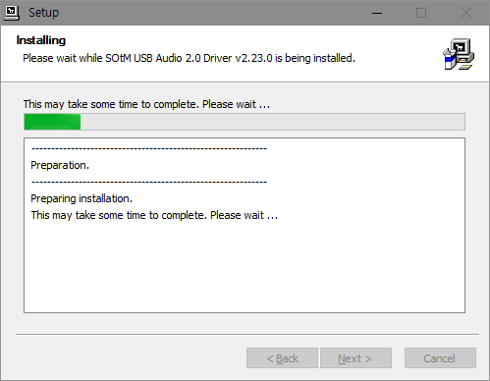
And installation is started. Press the “Next” button to go to the final stage once the setup is completed.
Caution : Depends on USB audio class 2.0 driver version, the unit should be connected to PC by USB cable, and install the driver while the unit is in operation.
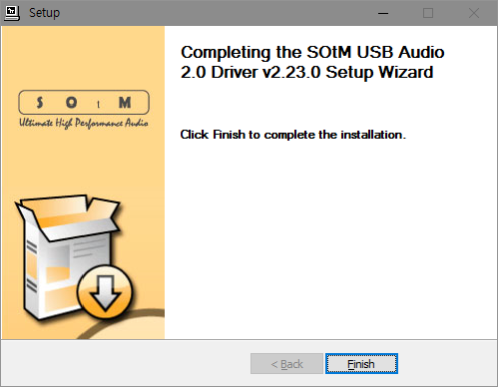
To complete the installation the driver, please click the “Finish” button.

Control Panel
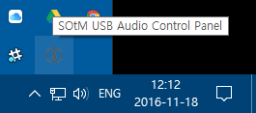
SOtM USB Audio Control Panel’s icon will appear on the task bar once the installation has finished.
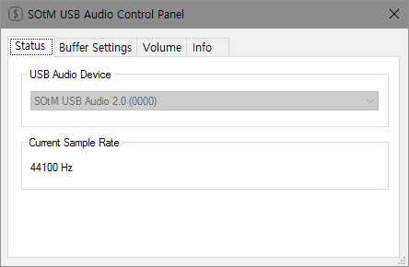
Please double click the Control Panel icon and then the driver information will appear, you can check the driver version information and etc.
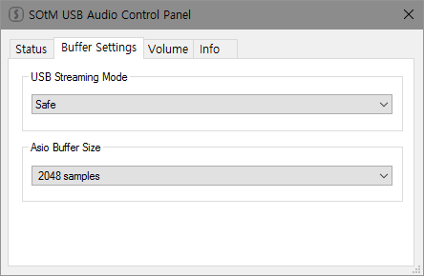
If you select “Buffer Settings”, you can adjust the streaming Buffer Size and ASIO Buffer Size.
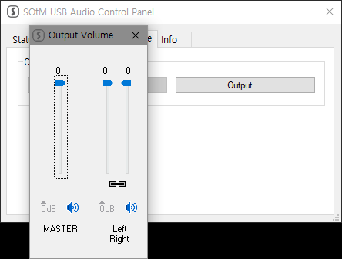
The Volume Control will be shown as the below image, and you can control the maximum(0dB) and minimum(Mute) values by the buttons or the slide bars.

Upgrade Firmware
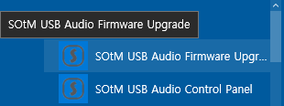
Start firmware upgrade application.
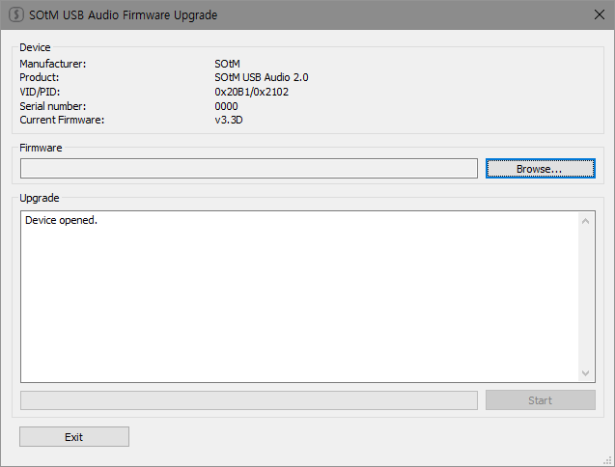
Window of firmware upgrade application.
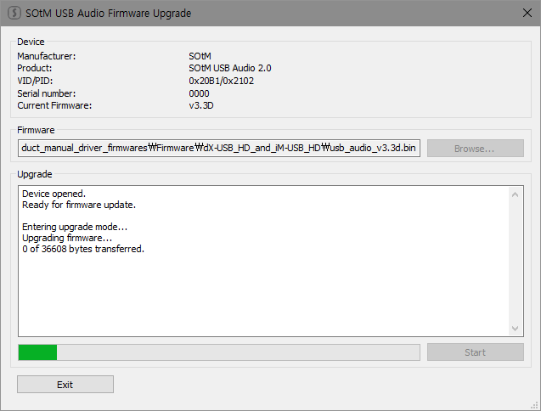
Select firmware file and start upgrade.
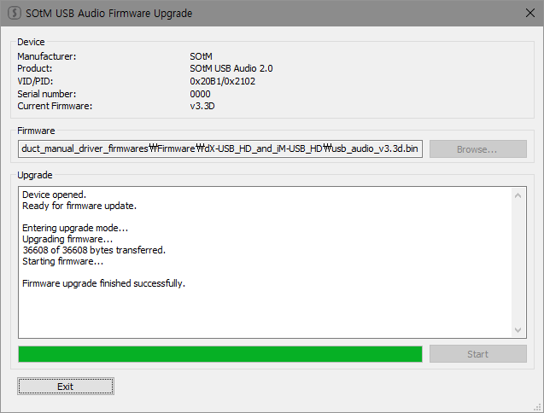
Finish upgrade.
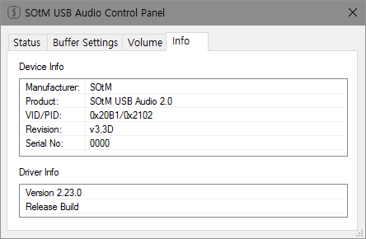
You can see result of upgrade in control panel.

