Burning mSD card image
How to load Eunhasu image to the micro SD card.

Windows OS

Preparation
- Download the new micro SD card image(.gz) and unzip it. Please note the image file is quite big.
- Download the imageUSB utility and unzip it.
- Press gently on the micro SD card in the micro SD card slot on the rear panel of sMS-200 to take out, and insert it to a micro SD card reader. The micro SD card slot is “push-push type”, so after loading the image file to the micro SD card, you can insert the micro SD card back to the micro sd card slot. Once it's inserted well, you will hear a click sound.

Run imageUSB
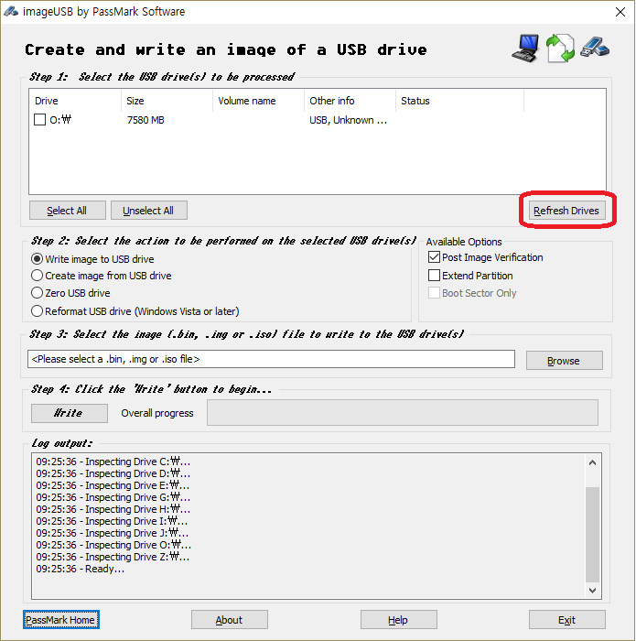
Run imageUSB. The connected USB device will be shown up. If the connected USB device is not shown, click 'Refresh Drives'.

Select a USB device
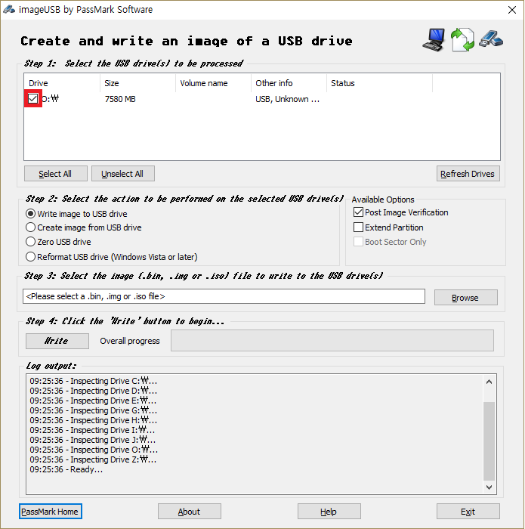
Select an USB device to write the new image file.

Select the new image file
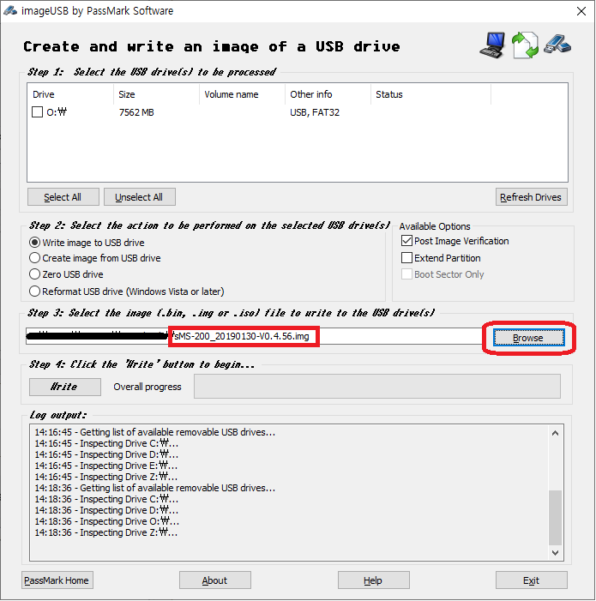
Click 'Browse' button and select the downloaded image file.

Write the new image
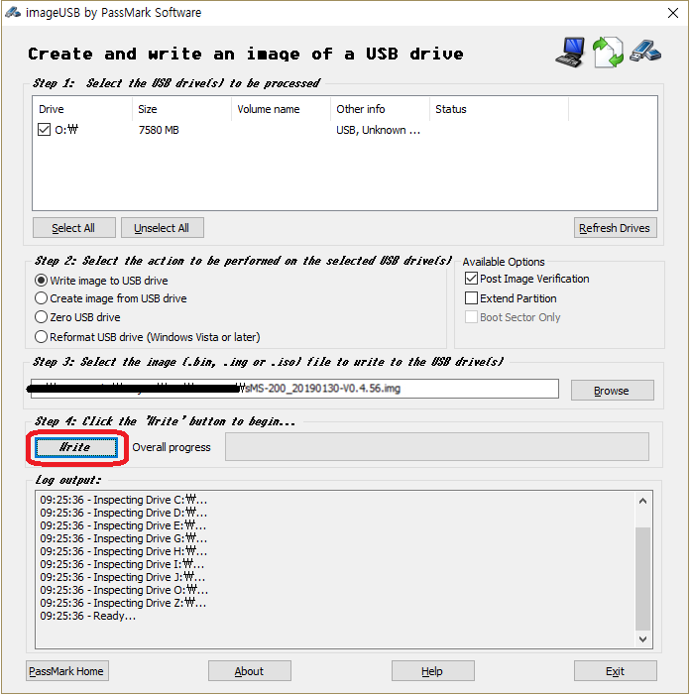
Click 'Write' button to write the new image file to the micro SD card.

Finish
- Insert the micro SD card back to the micro sd card slot on the rear panel of the sMS-200 or sMS-200ultra.
- Power on the device, and check that the device works fine.

How to format the micro sd card in Windows OS
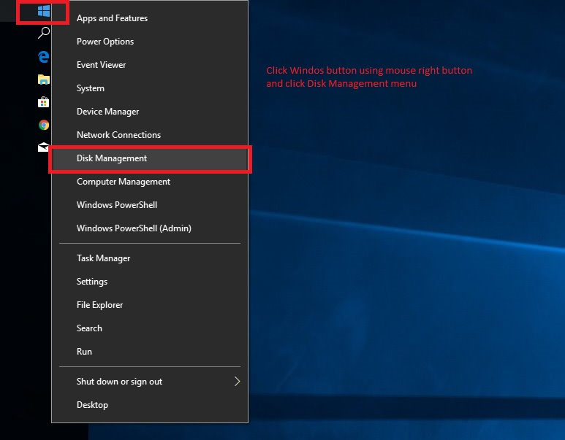
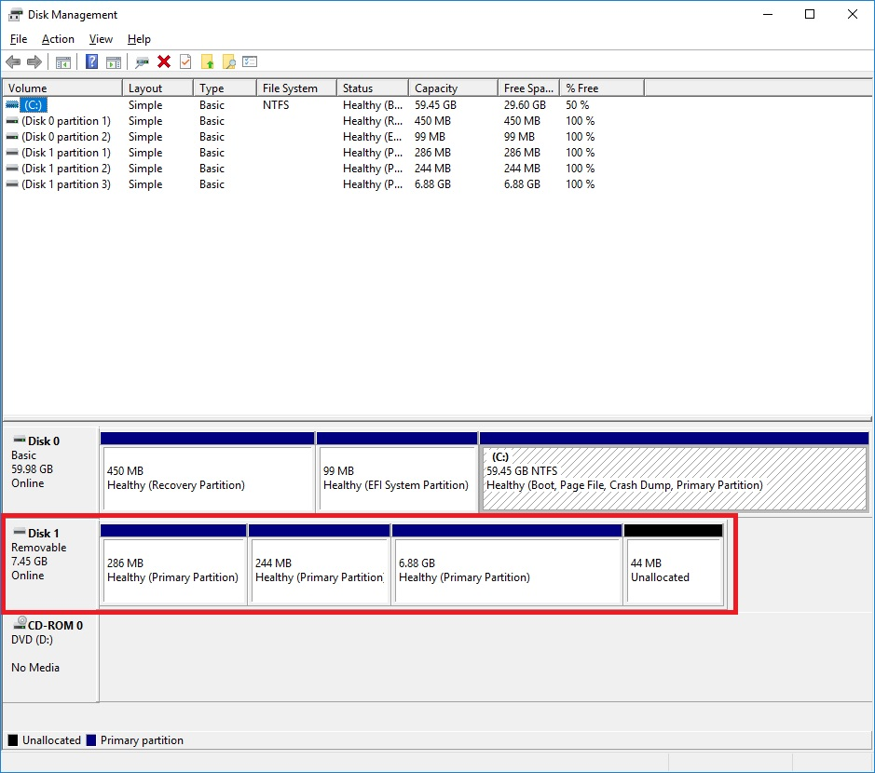
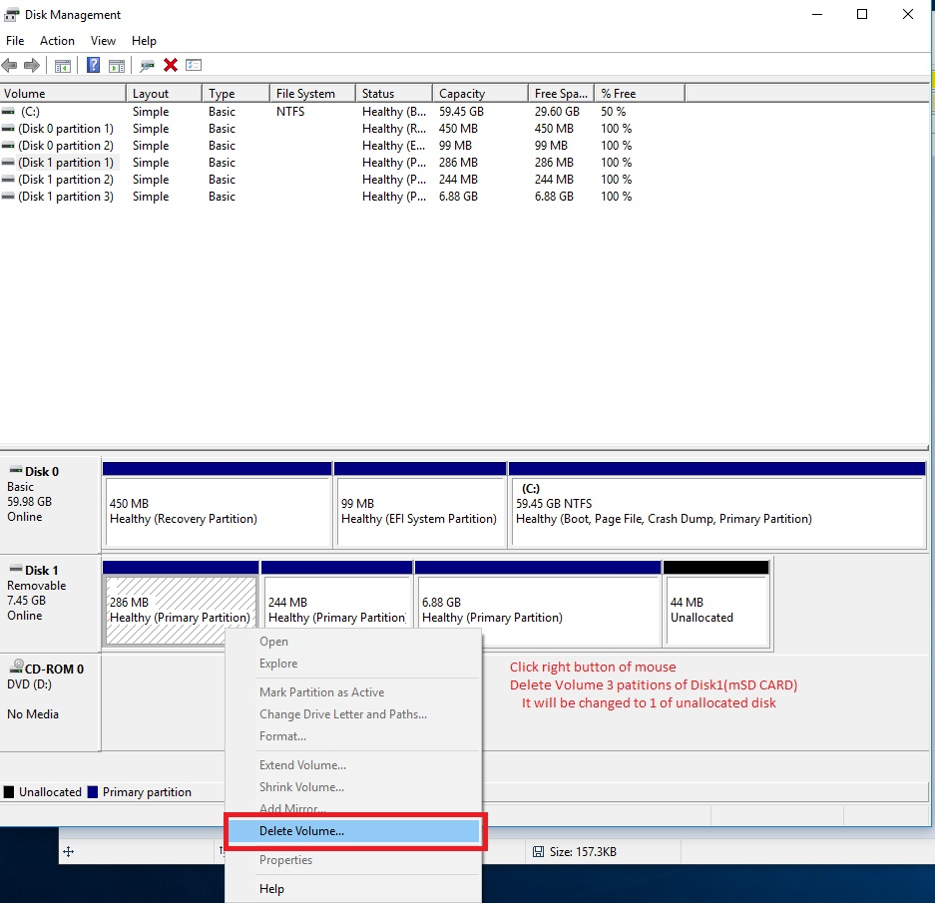
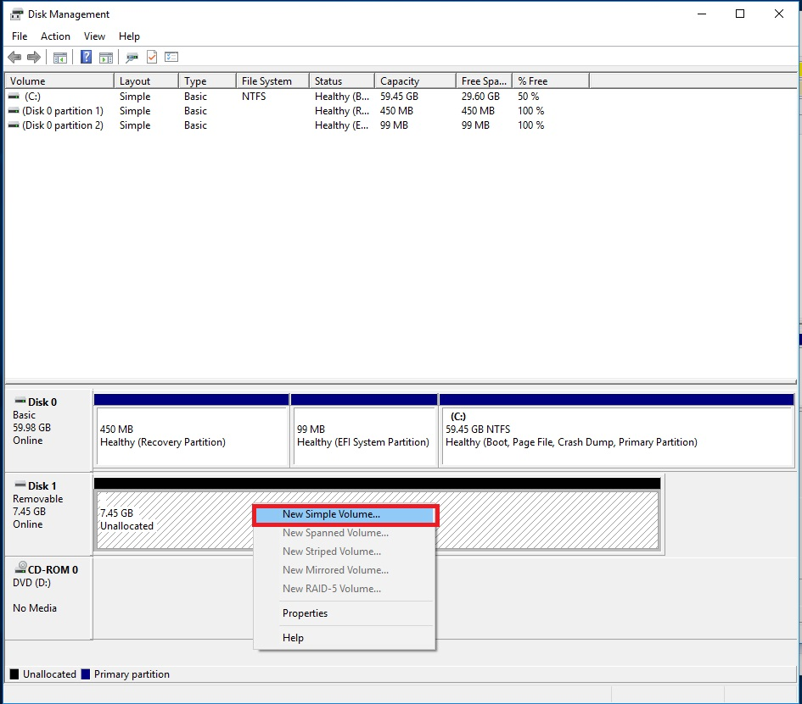
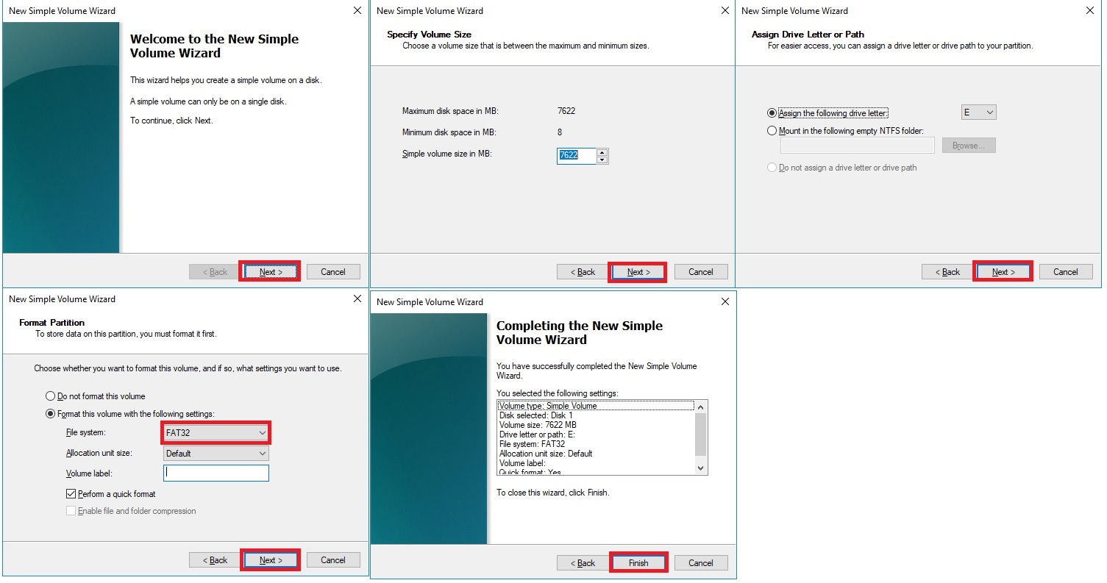
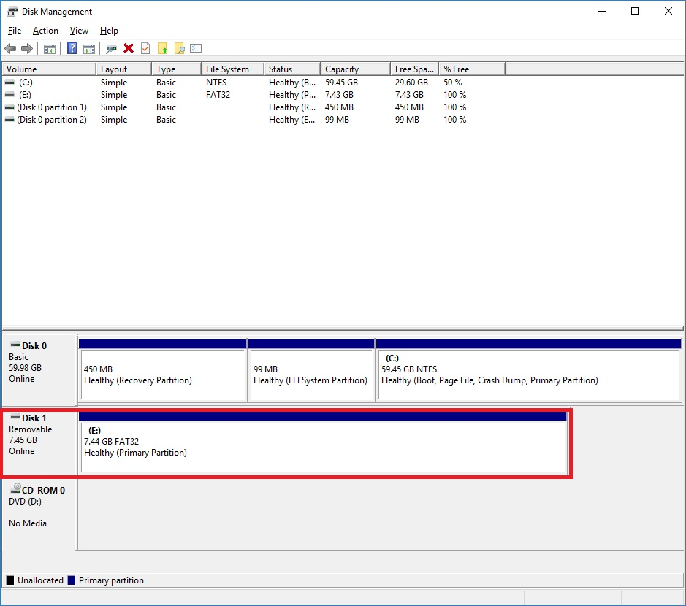
Please follow the steps as pictured.

macOS

Preparation
- Download the new micro SD card image. Please note that the image file is quite big.
- Download the dd-utility from here or github. And install it.
- Eject the micro SD card from the rear panel of the sMS-200 and insert it into a PC's USB port using a micro SD card reader.

Start Restore
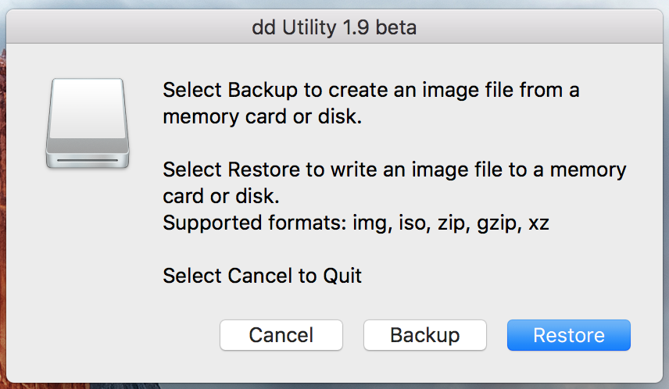
Click 'Restore' and select the downloaded .img file.
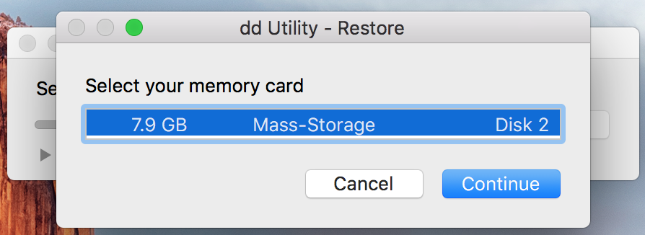
Select mSD card.
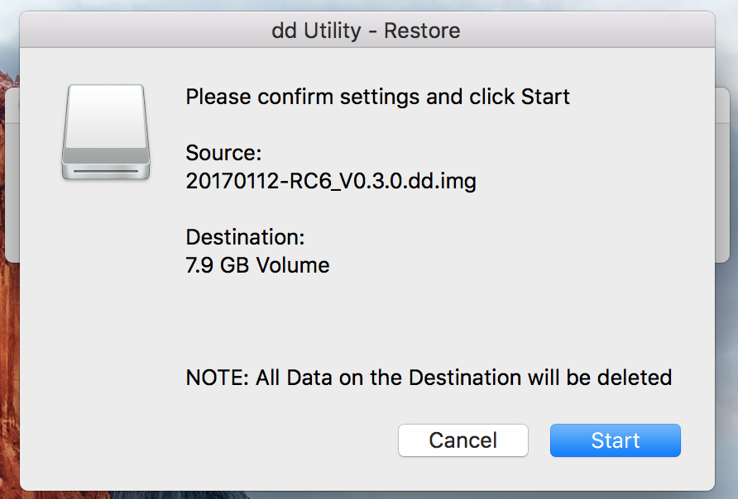
And start.
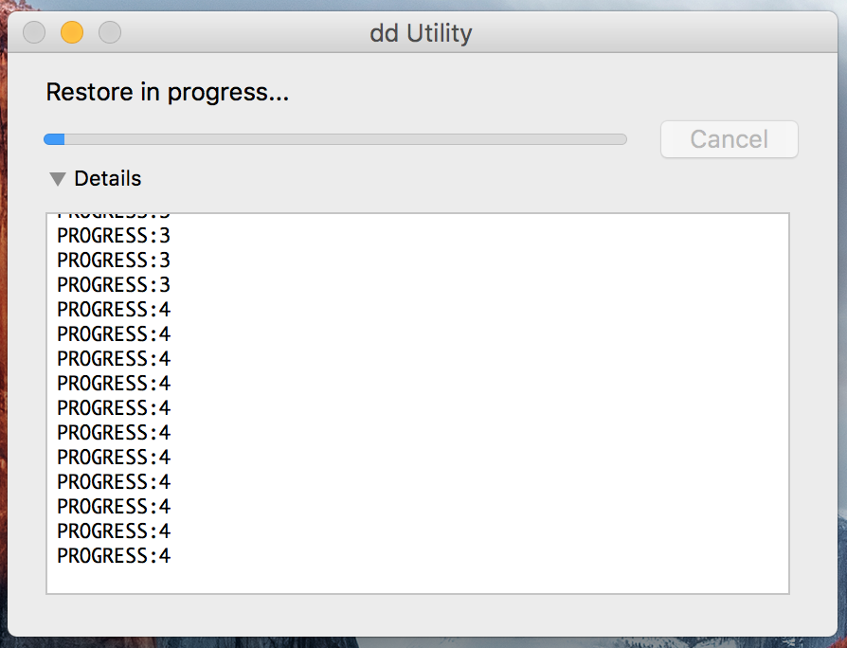
You can see the progress.
After finishing the process above, insert the mSD card to the mSD card slot of the sMS-200 or sMS-200ultra rear panel.
You can also use command-line by terminal instead of dd utility. Refer to here.

Downloads

Utilities
- ImageUSB for Windows
- Rufus tool for windows. You can use rufus tool if imageUSB tool is not work properly
- dd-utility for macOS
- Etcher tool If the other utilities won't work properly in your computer, please try Etcher as a workaround

micro SD card image files
- Eunhasu V0.4.22
- Eunhasu V0.5.1
- Eunhasu V0.5.2
- Eunhasu V0.5.31
- Eunhasu V0.5.41
If file name ends .gz or .zip, you need to extract using a separate utility.
If you are not able to complete the process successfully at the end of these steps, please check this video, https://youtu.be/ty_HN2gqJtQ. A few unzip utilities can't unzip the files completely and the unzip process may need 2 times in the progress, the video was made by one of our valuable customers, and thanks to HC.

