CD Ripping
Supportive file format is aiff, mp3, wav and flac. When you set 'Automatic' ripping mode, ripping would be started right after an optical disc is inserted to the drive. The ripping results path cannot be changed, and the path is only available when copying the result to the clipboard.
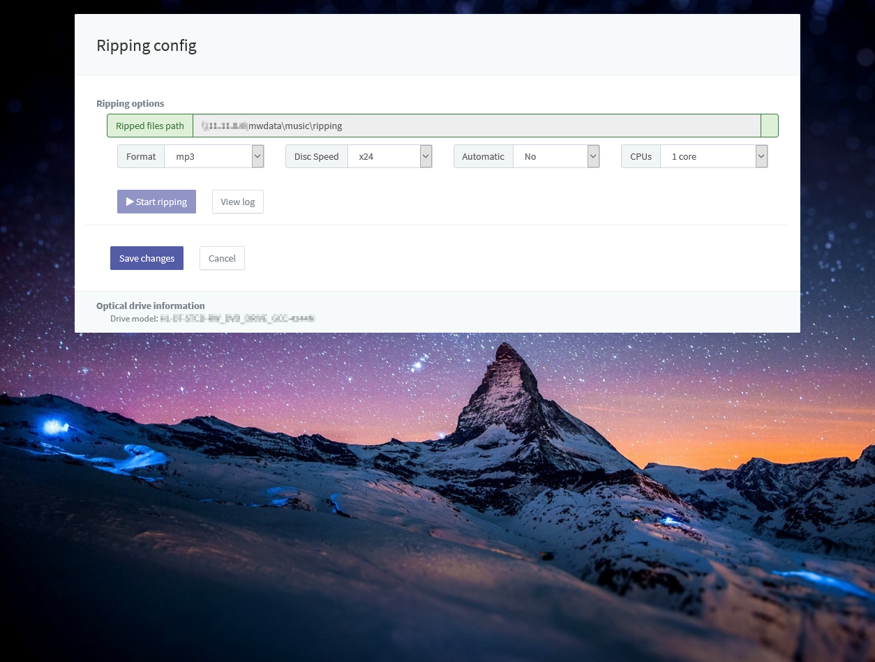
Check the optical disk drive first before you try to rip.

